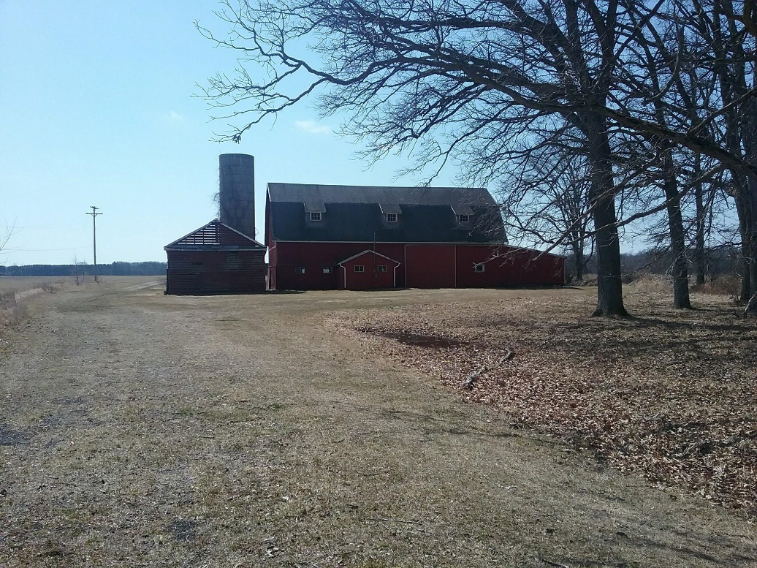
After some shaky times, the Midland Conservation District and the historic Tomlinson barn, are on solid ground.
Like the Tomlinson barn, the Midland Conservation District was also in jeopardy in recent years. The district closed its doors in 2012 and sold its office in Sanford in 2015 to have operating money. The district re-organized and resumed operations at the USDA Service Center in Midland. The barn and the district also have history together, said Midland Conservation District Manager Karen Thurlow. The conservation district took ownership of the Tomlinson Family barn and approximately 5 acres, which was part of the Midland County’s Pinecrest Farm on August 24, 2019, just over two years after Midland County Commissioners voted to have it torn down in June 2017. The barn is located just west of the intersection of Homer and Olson Rd. in Homer Township, Midland County west of the city of Midland, was built in 1912 by the Edward Tomlinson family. The county purchased the barn and 160-acre farmstead in 1968 with a donation they received from Dorothy Arbury, who was the granddaughter of Herbert Henry Dow, she was part of one of Midlands Founding Families.
The district leased the barn from the county for approximately 30 years and held their annual tree sales and Pheasant sales, along with other activities there.
When news of the county’s decision to tear down the barn came out, Thurlow was determined to save it. There were other county residents who felt the same way and Thurlow began contacting township supervisors, county commissioners, local foundations and organizations to seek support for saving it. “I was the squeaky wheel,” Thurlow said. No one knew we wanted to use it, so going public with my quest made it happen.
After months of negotiations, the county agreed to sell the barn to the conservation district in September of 2018. The district purchased the barn, along with 5 acres of surrounding property for about $47,000. Two anonymous, private citizens donated $35,000 and $25,000, for the purchase, said Thurlow. The funds remaining after the purchase will help pay for needed renovations including a new roof and restoring electrical and water services to the building.
“I think it’s a great accomplishment,” Thurlow said of the district buying the building. We saved a Barn, how cool is that!
Along with restoring the barn as the site of its tree sales, the district is interested in using the barn to host educational workshops and as a site to highlight county agricultural history. I think that the farming history is very important to the community too and those families should not go unrecognized, their stories should be told. Thurlow said. The district is currently collecting the histories of the county’s early farming families. Other projects we have planned include; an interpretive trail through a wooded portion of the property, pollinator plot, native plant sales, a high tunnel, garden plots, also a place to store our Earth and Water Tunnels. These are Educational tunnels we have for rent and take to events and schools to teach the Water Cycle and the “Secrets of the soil.”
Co-locating with NRCS at the Midland Service Center has helped establish a relationship with area farmers, said Thurlow. We have really come a long way since 2015. The district obtained grant funding from NACD and NRCS to help with Technical Support to NRCS and in July was able to hire a second employee. With continued support, Thurlow is confident the district will be able to continue its mission of supporting resource conservation in the county.

