Keys to Successful Tree Planting
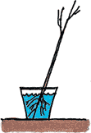
1. Unpack your trees, remove all packing materials, carefully untangle the roots and soak the roots in water 3 to 6 hours. Do not allow the roots to dry out. Keep in a cool place, Use Tree gel.

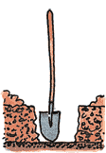
2. Dig a hole, wider than seems necessary, so the roots can grow outward without crowding. Carefully spread the roots. No J or L rooting.
Remove any grass within a 3-foot circular area. To aid root growth, turn up soil in an area up to 3 feet in diameter.

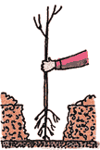
3. Plant the tree at the same depth it stood in the nursery, with plenty of room for the roots. Partially fill the hole, firming the soil around the lower roots. Do not add soil amendments such as peat or bark. Do not use fertilizer, potting soil, or chemicals on your new trees. Such products will kill your young trees

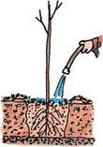
4. Crumble the soil removed from the hole and cover the roots. As you are adding soil lightly tamp the soil to collapse air pockets. Air pockets will kill your tree.
Do not add new or different soil.
Adding water also helps. Shovel in the remaining soil. It should be firmly but not tightly packed. Construct a water-holding basin around the tree. Give the tree plenty of water. Ok to add soil at the top.

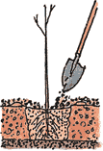
5. After the water has soaked in, spread protective mulch 2-4 inches deep in a 3-foot diameter area around the base of the tree, but not touching the trunk.

6. The soil and mulch around your trees should be kept moist but not soggy. During dry weather, generously water the tree every 7 to 10 days during the first year. Water slowly at the dripline. A 5 gallon bucket with holes in the bottom works well.

Top reasons tree plantings fail:
Improper care before planting, do not let roots dry out, Keep in cool place, improper planting, planting during the wrong time of year. Not matched to suitable soils, site preparation and maintenance.
If you have any question please contact the Midland Conservation District 989-486-2325

