Otsego Conservation Dist 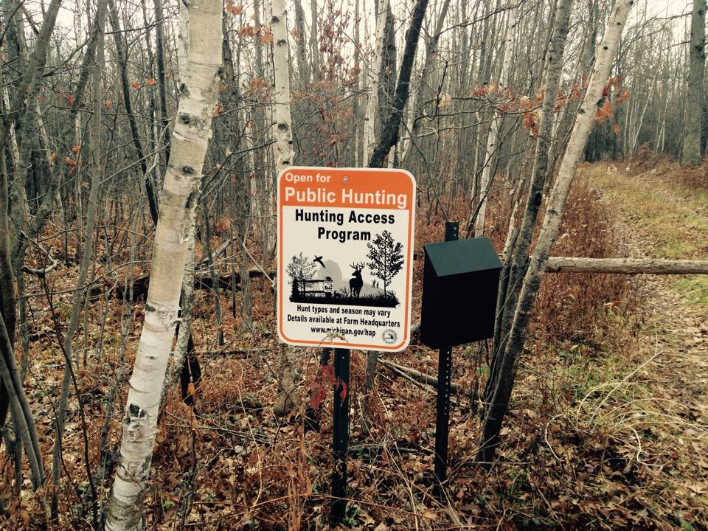rict

hunting access program

WHat is HAP?
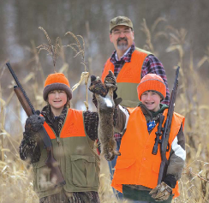
​HAP, the Hunting Access Program, is a financial opportunity for landowners that also provides public hunting opportunities in most counties in the Lower Peninsula of Michigan and is expanding every year. The DNR works with Conservation Districts to leases private lands from landowners who give licensed hunters access to their property, generally on a first-come, first-served basis. Hunters using HAP lands are guests of the landowner and are asked to register each time they visit the property.

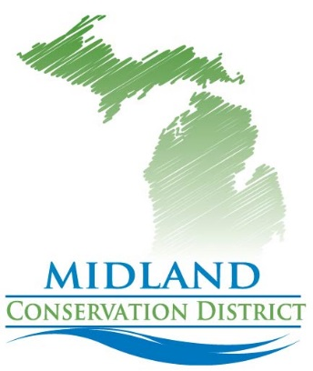

CONSERVATION District's Role

The DNR works with the conservation districts to make this program possible. The Midland Conservation District will work directly with landowners to set everything up and walk the landowners through any questions. The MCD District Administrator, Karen Thurlow, is the person in charge of the program in the county and the Landowners main contact. The MCD will:
- Meet with landowners
- Go over the land to make sure it is a suitable habitat
- Work with the landowner to come up guidelines for the property
- Put up the HAP signs and sign in station
- Continuously monitor the property to make sure everything is up and running

What's in it for the Landowner?
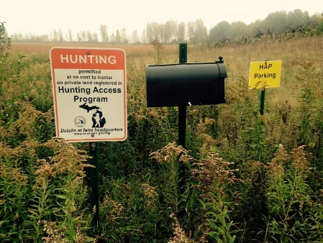
- ​HAP offers a chance to increase and diversify your farm/land income, while helping to control deer damage or nuisance wildlife.
- It's a way to allow controlled access on your land. Liability is covered by state law, and the program is flexible - you may choose to allow all hunting, youth and apprentice hunting only, small game only, deer only or turkey only or a combination.
- HAP offers landowners payment in exchange for providing hunters access to their property.
- Help preserve Michigan's hunting tradition - give hunters a place to hunt near home.
- Help support Michigan's rural economy.

WHo can enroll in HAP?
Landowners in Midland County, owning 40 or more acres, are eligible to apply. HAP contracts can include forest, wetland, grassland and cropland. A minimum of 20 percent of the contracted acres must be in wildlife habitat (grassland, forest or wetland). The land cannot be touching public state land.

​How do hap leases work?
​HAP provides an annual lease payment for acres enrolled in the program.
Lease amounts are based upon a combination of habitat quality, type(s) of hunting allowed and total acres enrolled. Maximum rates are paid for high-quality habitat. Properties enrolled into a Farm Bill program such as the Conservation Reserve Program (CRP). And allowing either all hunting or youth and apprentice hunting.
HAP can pay up to $25 per acre for high-quality habitat.
Conservation District staff will evaluate your land to determine the lease rate. Leases are negotiated for a two-year period with payments made at the end of each hunting season, usually in April.
If you’d like information on our CRP or EQIP programs contact the District.

WHat are the Hunter's RESPONSIBILITIES?

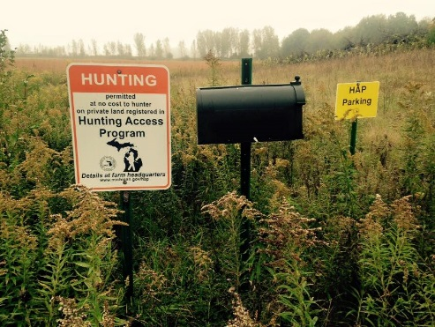

Hunters are asked to register daily if they are actively hunting.
Hunters must observe all instructions of the landowner, Know the property boundaries and not trespass on adjacent property.
Hunters are not to block field access routes or drive on property without the host's permission.
Leave no trash, if you bring something in, then take it out with you.
Hunters may only place tree stands or build blinds only with the landowner's permission. State land rules apply. Hunters must observe all hunting and trapping rules and regulations and stay out of standing crops and observe safety zones around buildings.

To learn more or to see if you are eligible, contact Karen Thurlow at
(989) 486-2325 or at midlandconservation@macd.org

