Join us for an Evening of Celebration
January 17, 2017 6:00pm- 9:00pm
Larkin Township Hall 3016 N. Jefferson Midland, MI 48642
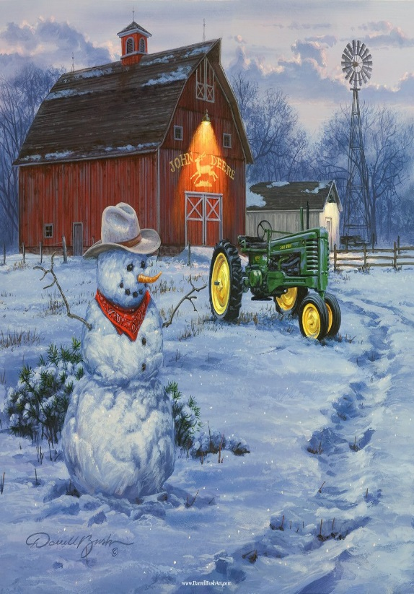  Happy New Year 2017 |  | Agenda:  Music & Mingle 5:30pm-6:00pm  Entertainment-The Midland Guitar Ensemble  Dinner 6:00pm  Catered by Shirlene’s Cuisine  *No charge for dinner, Donations are greatly appreciated  7:00pm-9:00pm  Speakers & Presentations  Karen Thurlow- Midland CD Annual Report  Ken Wawersik- MAEAP Phase 1  Boyd Byelich- NRCS Updates  Kyle Bagnall- Floods of Midlands Past
Midland co. Conservation District
954 E. Isabella Rd. Midland, MI 48640
Phone: 989-486-2325
E-MaiL : midlandconservation@macd.org
Website: http://www.midlandcd.org/

Please RSVP by January 13, 2017

