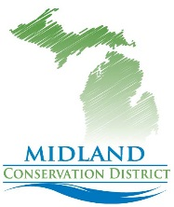

Conservation Matters
Midland Conservation District Quarterly News letter
Happy New Year!

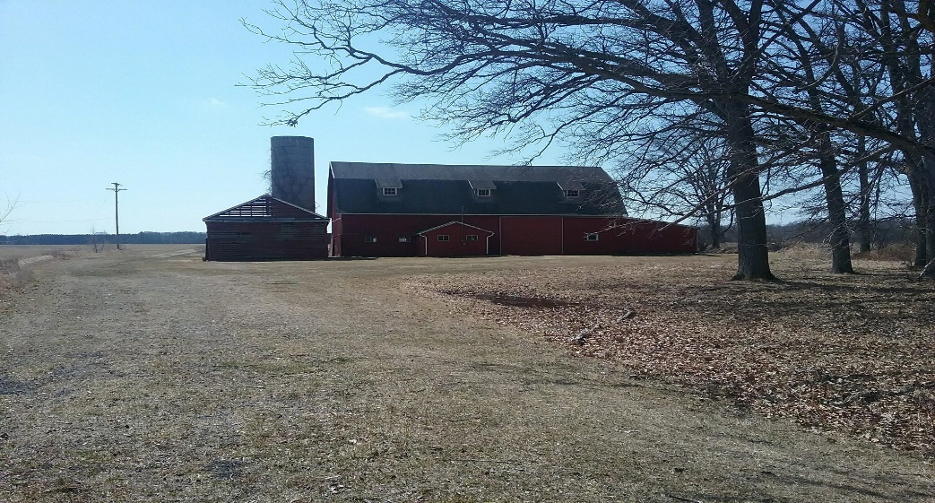

Commissioners voted 6-1 in September to sell us the Pinecrest Barn on Olson Rd, we are excited for this opportunity to save this Historical Barn and make it a community learning center.
We will be holding our Reforestation Tree Sales, Educational Work Shops and much more there! If you’d like to know more about the projects, we have in mind visit our web page or call the office.
We are still waiting on a closing date.

Annual Tree NOW through March 31, 2019

We’ve added Wildflower Seeds, Strawberries, Asparagus, Raspberries, Rain Barrels and take credit cards, checks or cash for orders.
Get your orders in now. Some quantities may sell out quickly.
Also seeking volunteers to help with distribution.
Tree Sale Distribution: April 17-20, 2019 (Subject to change.)

Conservation Matters on MCTV! We currently have 8 shows on our web site or watch them on MCTV.
You can now go to MCTV click on Watch now and search Conservation Matters on Community Channel and all our shows will appear.
Learn all about Who we are and What we do, Why Plant Trees, How to Plant Trees, Pollinators, Invasive and Natives, Hunting Access Program, Backyard Conservation, and Founding Fathers/Founding Farmers.

HAP Hunting Update: Due to the chronic wasting problem in Michigan, the DNR is focusing on properties in that area. We only have one property available here in Midland County.
Check www.michigan.gov/mihunt for an updated list of available HAP Properties.

Are you a Landowner? Would you like information on available cost sharing programs for conservation practices on your property?
USDA/Farm Service Agency/Natural Resource Conservation Service have programs to help
And information is always free!

Items for sale/donations at the office.
All proceeds are considered donations and help fund District Programs.

Conservation Matters T-Shirts Available $15.00

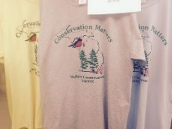Available in Hot Yellow, Grey and Light Blue.

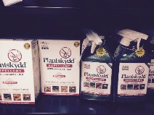 Plantskydd Repellent,
Proven safe & effective for 6 months.
1 Pound covers 400 plants, $30.00 or 1-quart Spray bottle covers 100 plants $22.00.
Considered Organic!

Books Available:
2018 edition Plat Books: New Price $30.00 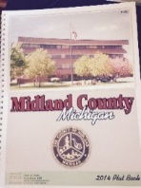
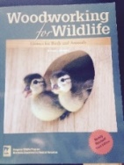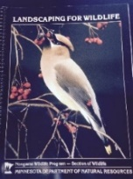
Woodworking for Wildlife: $18.00 Landscaping for Wildlife: $12.00

Wild Flower Seed Mix 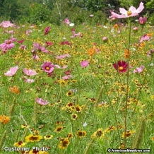 ¼ pound covers 250-500 square feet $15.00

Educational Tunnel Rental Program
Are you planning an event that teaches soil health or water cycle/water health?
We have 2 unique “tunnels” manufactured just for this purpose.

Earth/Soil Tunnel 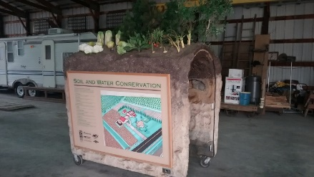

Water Cycle/Conservation Tunnel 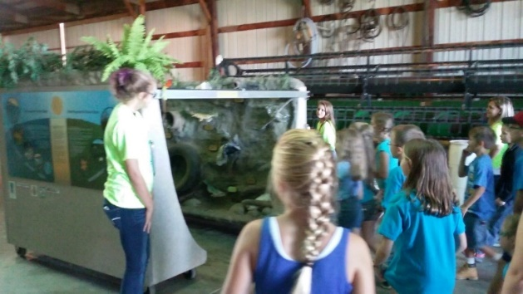
These educational tunnels are for rent through the district for events.
Contact us for details. Rental fees and deposit apply.
Quarterly Events and Programs
September was our annual budget meeting.
We have secured the purchase of the Pinecrest Farm Barn. And starting a NEW and exciting year full of opportunities.
Our Tree sale will be moving back to this location.
We will have monthly clean ups and workshops.
Please keep informed of upcoming events through our web page www.midlandcd.com and our Facebook page.

We are seeking Volunteers, Associate Directors, and Directors
Associate Directors and Directors work on committees and as volunteers at events.

Annual Report and Resource Assessment available on our web site.

MCTV Shows: New: 5th Grade Farm Tour and Dahlia Hill
Do you have a subject you’d like to see? Do you have an event you’d like us to record?

Annual Plan-Upcoming events:
2nd Quarter January 1, 2019 – March 30, 2019
Quarterly News Letter January. Happy New Year!
Annual Meeting Moved to May 19, 2019, Location and details to be announced
Hopefully at the Barn!
Work Shops- March: Why, When and How to Plant Trees, Location and Details TBA

3rd Quarter April 1, 2019 – June 30, 2019
Quarterly News Letter April.
Tree Sale Distribution: April 17-20, 2019 (STC)
Annual Meeting May 19, 2019. Details to be announced in April News letter.
Chippewa Nature Center “Experience Earth Day” (EED) 4-27-19 10am-4pm.
Work Shop May: Backyard Conservation Matters. Pot/Patio/Backyard Gardening
Location and Details TBA

4th Quarter July 1, 2019 – September 30, 2019
Quarterly News Letter July.
Appropriations Act Planning & Budget Planning: Budget meeting September.
Workshop June: Cover Crops and Soil Health Location and Details TBA

September 4th Grade Farm Tour Celebrated 31 Years on September 18, 2018
Hosted by Laurenz Family Farms. All Midland County 4th grade classes are invited.
If you’d like to donate time, money, supplies OR want your class to attend
contact us!
Midland Conservation District donates to bussing costs and sponsor 3 teaching stations.

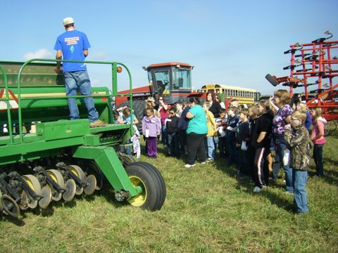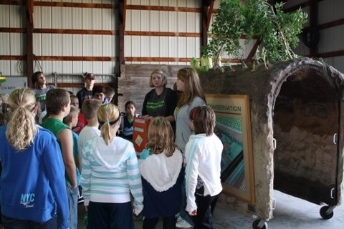

Thank you for your support!

For updates on activities listed:
Check out our Web Page: www.midlandcd.org
Like us on Face Book Connect with us on LinkedIn.
Contact us:
Phone: 989-486-2325 E-Mail: midlandconservation@macd.org
Get on our e-mail list. Like us on Face Book

Stopping by the office? Call ahead to make an appointment.
We may be out on a training or field visit, we’d hate to miss you!
Limited Hours: Monday, Wednesday and Friday 8:00am-4:30pm

The Midland Conservation District is an Equal Opportunity Employer and follows a policy of non-discrimination by race, creed, color, religion, age or sex in its appointments, promotions, compensation or other actions affecting its employees.

