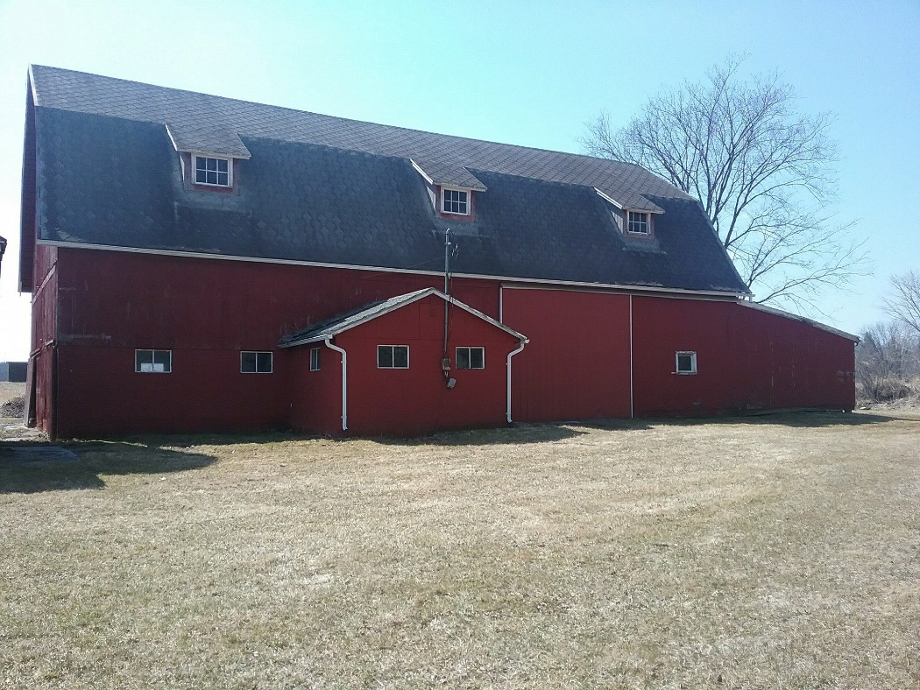
MIDLAND COUNTY (Pinecrest) COMMUNITY FARM
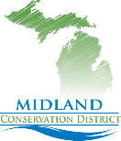 MIDLAND CONSERVATION DISTRICT
E. OLSON RD. MIDLAND, MI 48640
Operation Plan
The great story of American agriculture is one of hard work, ingenuity and passion,
And it’s a story best told by the folks who live it.

We view historic barns as cultural resources and heritage assets that are vital to understanding the history of our nation. These resources are irreplaceable and worthy of preservation.
The reasons to save our barns are many, particularly as their numbers continue to dwindle.
Across America, hundreds of individuals, families, towns, working farms and historical societies have declared that their barns will continue to be part of the visual landscape, as useful farm structures or beginning new lives as educational and community resources.
Aging barns dot America's rural landscape, rickety reminders of the hard work that built communities, but these iconic structures are slowly disappearing,
"The preservation of these barns is so important that we do it now while they're still standing because in 100 years from now they'll be gone forever

Help Protect America’s Disappearing Rural Heritage!
Brief History and Background of Midland Conservation District
Midland Conservation District (MCD) is one of 75 Conservation Districts in Michigan.
Michigan Conservation Districts are “unique” local units of State Government, established to carry out conservation programs and community education. Conservation Districts utilize state, federal, and private sector resources to assist people with the use and protection of natural resources on the lands. MCD was established in 1951.
Conservation Districts scan the needs of local communities, work in partnership with others in the community to set local priorities and develop action plans to solve natural resource problems, allowing citizens to manage their private lands for a cleaner, healthier Michigan.
The MCD is governed by an elected, five-member Board of Directors. The Directors make decisions regarding District’s programs and activities and hire qualified staff. The staff provides information, technical assistance, creates workshops, public education, and cost-share opportunities, as well as affordable trees/shrubs to enhance wildlife and reforestation.
The Mission: Provide a gateway for information, conservation education and partnership and focus on resource concerns of the community, including Water, Air and Soil quality.
Goals: To foster a partnership between the community, local, state, and federal government agencies in creating and implementing programs, and educational workshops that pertain to the soil and water conservation, agricultural history and to remain economical stable.
Programs: The MCD assists landowners, land managers and community members with information to better manage conservation, wildlife and forestry goals. Providing professional natural resource guidance and assistance in the development of private land projects. Providing technical information as well as information on existing programs and financial assistance.

Project Description
Barns are historic community resources and should be saved. In the past from approx. 1991-2012 the MCD leased this barn for tree sales and storage, we helped maintain and do over $30,000.00 in repairs during this time with funding from foundations, however when the district closed for a short period the agreement was lost. We see this barn as an asset to MCD and the community.
After closing in December of 2012, the board reorganized in August of 2014 and got back to business officially in May of 2015. We have been sustainable and working with the community and partners and regaining public trust.
With your support we can Save a piece of history, use that property to become financially stable and create a thriving resource for conservation education in the community, supplying native trees, shrubs and plants, providing educational programs and workshops with focus on America's rural heritage and Michigan Agriculture.

SHORT TREM GOALS
Secure and Monitor, Clean up, Minor repairs
Assess repairs and prioritize
LONG TERM GOALS
Roof, Paint,
Water, Electricity
Parking Area Improvement
High Tunnel/ Green House
Recycling station/ Tires, Hazardous Waste, Computers etc.
PLANNED ACTIVITIES (funding opportunities)
Spring Tree and Native Plant Sale
Yearly Orders taken Feb. 1 through April 1, distribution week before Earth Day
Addition of a Fall Tree Sale
Annual Meeting & Community Picnic

Educational Classes & Workshops
Tree Planting Soil & Water Health
Back Yard Conservation Grow your own Food/Gardening Education
Our Administrator is certified in Project Learning Tree (NRCS) and Project Wild (DNR)
And very committed in creating educational programs and workshops for children.

Community Barn Sale
Take Donations and have Sale during City wide yard sales.
Education Tunnel Rentals
We have 2 educational tunnels that are rented out to organizations for educational purposes, Teaching Soil and Water Conservation.
Other Uses
This is an opportunity to create an outdoor education/learning area.
The barn would provide a space to conduct workshops and trainings.
The property could be used to plant windbreaks, native plant gardens, trees, and small food plots, for identification purposes that could be used for hands on workshops.

Saving the Barn and its history for future generations.
Your support is greatly appreciated.

