Midland

Conservation District
  - Annual Report 2020
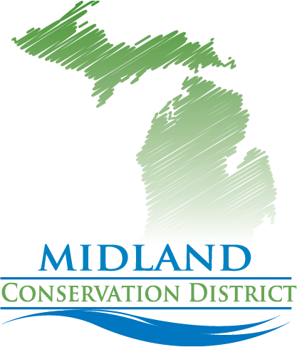
TAKING CARE OF THE EARTH, TO FEED THE WORLD
Prepared By: Thurlow, Karen | – MCD District Manager | 2020
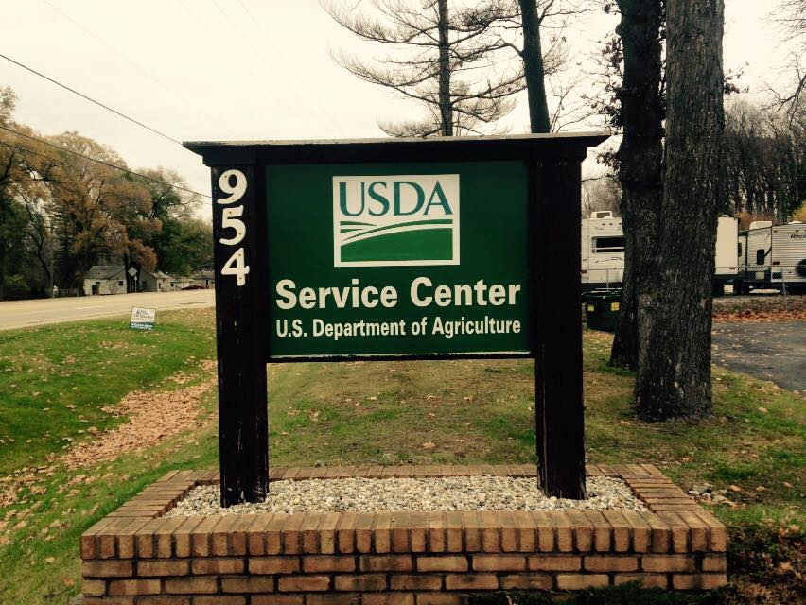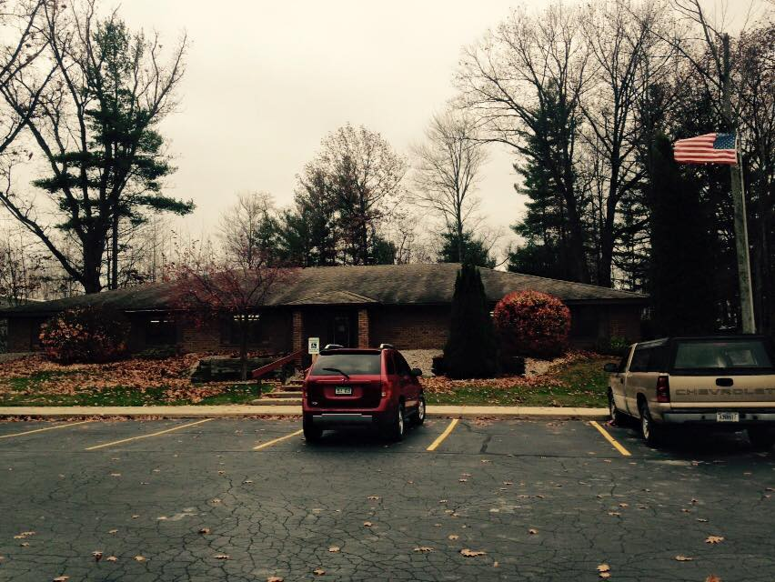
We are co-located and working with the USDA/NRCS Office.
Promoting Conservation Practices and Planning in Midland Co.

Office Hours and Contact Information:
Location-954 E Isabella Rd Midland, MI 48640.
Co-located with the NRCS office in the Midland USDA Service Center.

New Hours: Monday through Friday 8:00am-4:30pm
Phone: 989-486-2325
Email: midlandconservation@macd.org
Web Page: http://www.midlandcd.org/
We are also on Facebook

History of the District
The Midland Conservation District was developed on June 27, 1950 as a unit of government.
The Midland Conservation District is one of 78 Conservation District in Michigan.
Michigan Conservation Districts are “unique” local units of State Government, established to carry out conservation programs. Conservation Districts utilize state, federal, and private sector resources to assist people with the wise use and protection of the natural resources on their lands. We held our first tree sale in 1951.
Conservation Districts continually scan the needs of their local communities, work in partnership with others involved in conservation to set local priorities and develop action plans to solve natural resource problems. The delivery of these efforts by Conservation Districts allows citizens to manage their private lands for a cleaner, healthier Michigan.
The Midland Conservation District is governed by a locally elected, five-member Board of Directors. The Directors make decisions regarding the District’s programs and activities and hire qualified staff. The staff provides information, conservation planning, technical assistance, workshops, public education, and cost-share opportunities, as well as the Annual Tree Sale, selling trees/shrubs to enhance wildlife and reforestation.

This district was shut down in December 2012 after the state invalidated an election of board of directors. In August of 2014 the state appointed 5 board of directors that were selected from letters of interest that had been submitted. The current board has been working on the reestablishment of programs and funding and regaining community support.
We are currently looking for Associate Directors, and volunteers. Contact us if you are interested.

Current Board of Directors

Annual Meeting and Election May 19, 2020.
We are taking petitions from community supporters that would like to help us and will have an election at the annual meeting. We currently have an opening for 1 board member.
Having a working, informed board is what makes the district a success. Board members help make decisions and work with the District Administrator/Manager with district operations.
Karen Thurlow: Administrator/District Manager- has been a business manager for over 40 years, is a business owner of Beyond Measure Bulk Foods, a Farmer & Beekeeper and has lived in Midland all her life. Karen is passionate about conservation practices of all types, youth education about conservation and agriculture are a big priority. She is certified in environmental education programs, Project Learning Tree (American Forest Foundation) and Project Wild (DNR) Karen is currently on the Coleman Agriscience Advisory Board and Land Lab Planning Committee. She also is a volunteer at MCTV and Dahlia Hill.
Karen was appointed by the state as a board member in 2014 to restart the district after a brief shut down and has been the administrator since January of 2015.

Laura Norcutt: Chair- Retired Federal Wildlife Biologist with 32 years working for the US Peace Corps, USDA and US Fish and Wildlife Service. Experience includes aquaculture, wildlife damage management, natural resource plan development, and aquatic invasive species. In October 2017 moved to Midland County with husband to 40 acre property in Sanford. We plan to manage it for wildlife, honey bees, chickens, vegetables and fruit. Laura also wants to work with the community to help promote renewable land management and sustainable agricultural practices.
Mary Johnson: Vice Chair Director holds a BA from the University of Michigan. She is a retired social worker and has been a Master Gardener Volunteer for Michigan State University since 1993. She and her husband own a small, 8 acre, property in Midland County where they grow flowers and vegetables. Gardening, preservation of farm life and the enjoyment of the outdoors are very important parts of her life. As a member of the Midland County Master Gardener Association, she is committed to encouraging good gardening practices and IPM.
Jan Ruhle
Cindy Poole Director Is a Retired Chiropractor who practiced for 38 yrs. I raised a family in the surrounding community. It was my life’s mission and work to care for patients concerned about their wellbeing. It is an easy fit to be involved in the Midland Conservation District for the health of our environment and the resultant benefit to our world.
David Ruhle: Director was born and raised in the community on a family farm. An experienced retired Bridge builder involved with structural engineering. Close to the environment and conservation daily. Is involved in gardening, farming and has a cow-calf operation.
He wants to help build a stronger community with the Midland Conservation District.

Nathanael Gentle Technical Assistant has a bachelor’s degree in biology with minors in both chemistry and geography from Saginaw Valley State University. He has an array of work experiences researching water quality in the Saginaw Bay Watershed and teaching the importance of science and conservation to others. Growing up in the Great Lakes Bay Region, he has a background with gardening and raising a variety of farm animals. Nathanael is passionate about the environment and is an avid outdoors man. His career goals are to work to ensure the many natural features we get to enjoy will be around for generations to come. He is also passionate about educating others. Nathanael is excited to be working with the Midland Conservation District, having the opportunity to help others be good stewards of the land.

Paul Holowka the District Conservationist in the Midland USDA/NRCS Office

Midland Conservation District Funding
The Midland Conservation District does not currently receive funding through operational grants from the State of Michigan (MDARD). Midland Conservation District does receive funding to oversee the DNR HAP (Hunting Access Program) and a cooperative agreement with the NRCS office which puts a full-time employee in the office for the fiscal year 2020. We also received a grant from the NACD (National Association of Conservation Districts) to hire a full time Program Technician to help with NRCS cost sharing programs and conservation planning.
Other resources: We have 2 unique Educational tools, a Water Tunnel and Earth Tunnel used to educate on soil and water health and used for many events around the state. They are available for rent through the District. Rental fees go into maintenance and promotion for the trailers and educational programs.
We also provide Midland County Platt Books, Woodworking for Wildlife, Landscaping for Wildlife, Plantskydd (Organic Varmint Repellent), Wildflower Seeds and T-Shirts help with funding for district activities.
Donations from public sources were minimal.
All Donations go to outreach for education and conservation projects in our area

Tomlinson Family Barn
In August 2019 we purchased a Barn and 5 acres from the County of Midland.
It was part of the 162-acre Pinecrest Farm.
We will be using the location for our Annual Tree Sales and an Educational Center for workshops and field days.

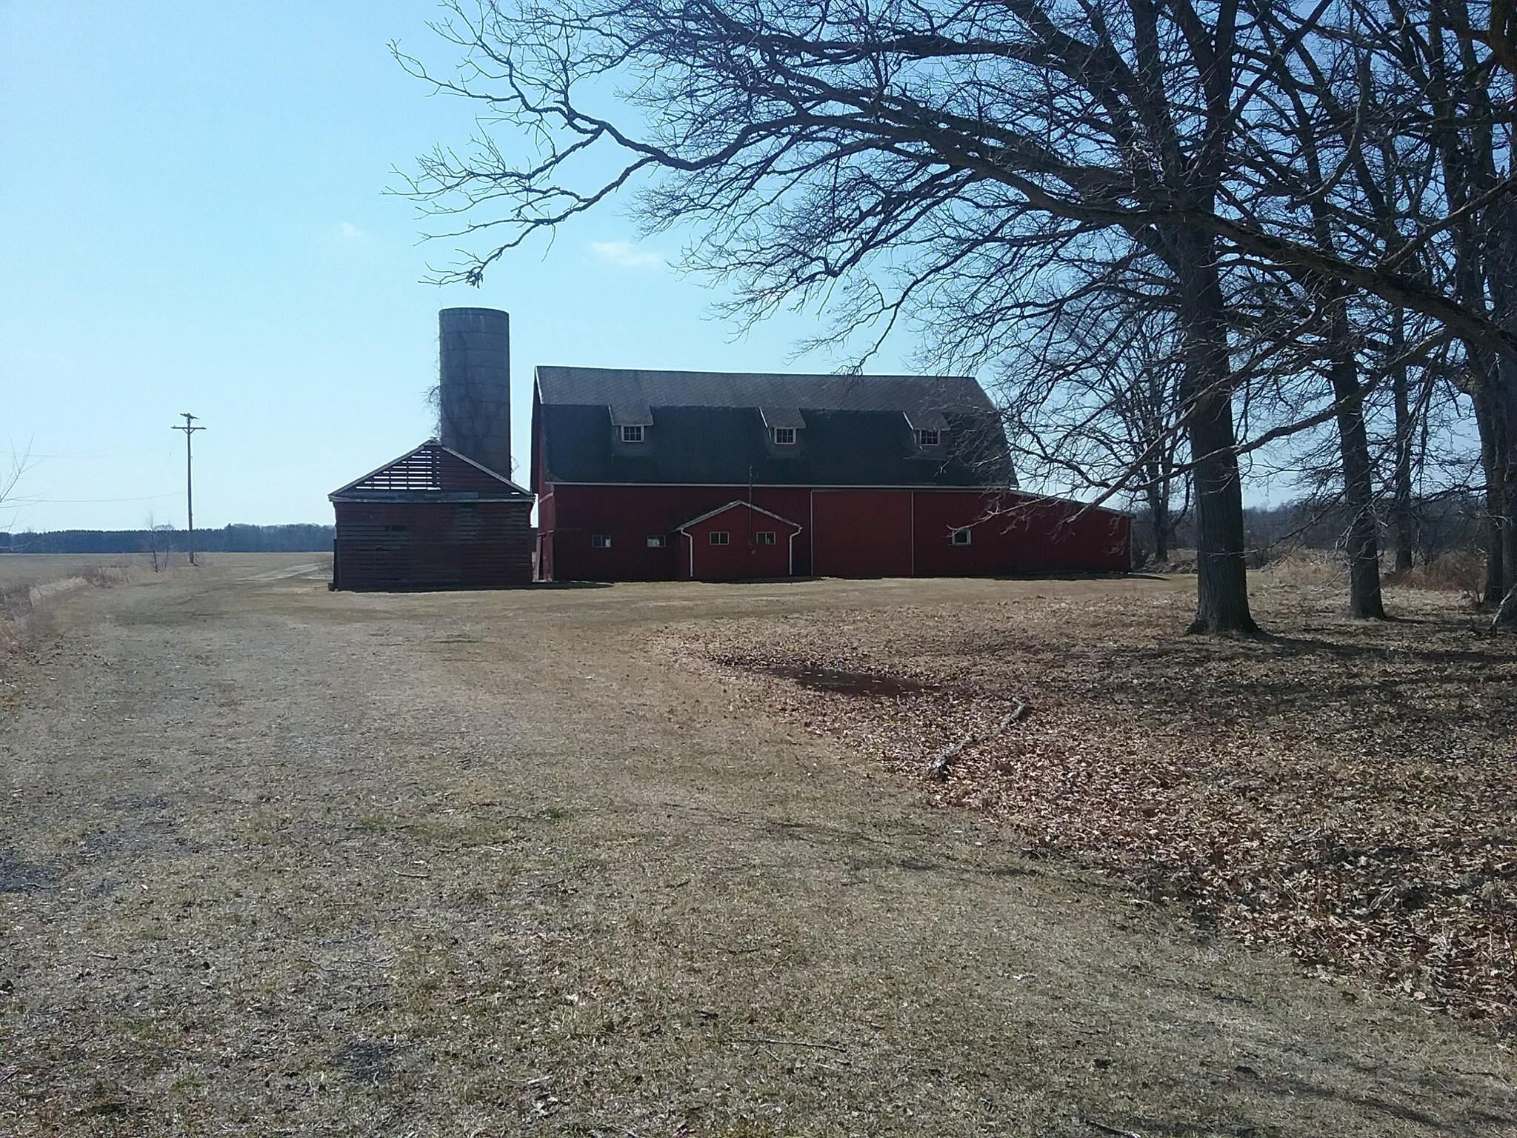
Saving a piece of Midland County Agricultural History

Helping People Help the Land.

Midland Conservation District provides Technical Assistance to NRCS.
NRCS provides cost sharing programs to land owners in Midland County.
Programs include

EQIP- Environmental Quality Incentives Program, provides financial and technical assistance to producers in order to address natural resource concerns and deliver environmental benefits, such as improved water quality, conserved ground and surface water, reduce soil erosion and sedimentation and improve or create wild life habitat.

MAEAP- (Michigan Agriculture Environmental Assurance Progra)- A proactive, voluntary program created to help all farmers to address environmental risks on farms and forests. A 3 phase program addressing education, on farm assessments & verification. MAEAP allows farmers to be proactive and proud of their environmental stewardship. It promotes effective land stewardship practices that comply with state and federal regulations.

FMP- (Forest Management Plans) A forest management plan outlines your family’s vision for your forest, describes the current forest condition, and outlines a plan of action to achieve your management goals. A forest management plan is not just about the trees. It encompasses all the resources on your property – roads, water sources, wildlife habitat, recreational sites, and anything else that is relevant to your family and your goals. A plan can help you keep track of activities, communicate with family members and professionals, and earn green certification for your forest.

CSP-Conservation Stewardship Program helps landowners build on existing conservation efforts. We can custom a plan to help you improve grazing conditions, increase crop land or develop wildlife habitat. We can help you find new ways to meet your conservation goals

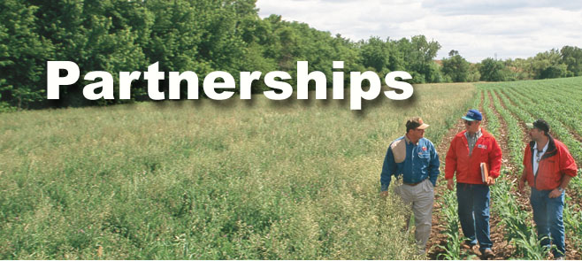

The great story of American agriculture is one of hard work,
ingenuity and passion, and it’s a story best told by the folks who live it.

Conservation District Practices Established:

Annual Reforestation Tree and Shrub Sale
The District makes available tree and shrubs that are compatible with USDA Conservation practices and Native to Michigan.
Orders for the Tree Sale are taken annually January thru March.
Delivery is the 3rd week in April. We are looking to add Native Plants and Seeds to our Sale.

Look for order forms and details on our website. www.midlandcd.org
The Annual Tree Sale is currently our main source of funding.

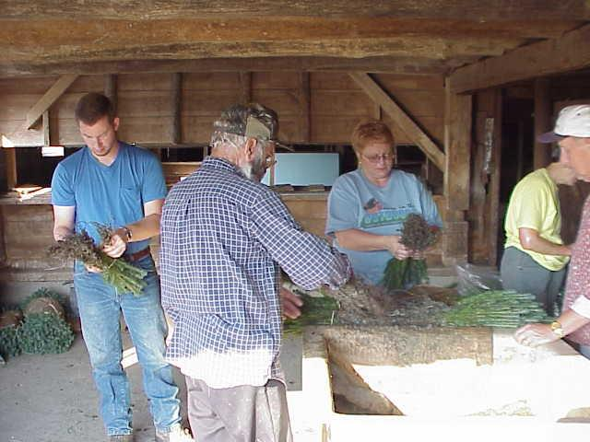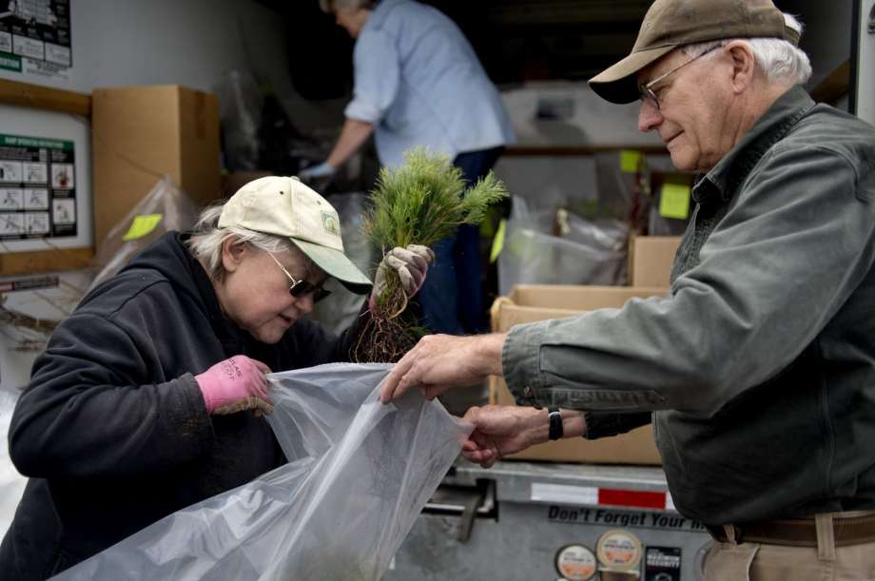

Experience Earth Day at Chippewa Nature Center

Midland Conservation District has been a guest at the Chippewa Nature Center for the past 3 years along with other conservation partners creating a fun filled day for families of the area.
We give away Michigan State Tree seedlings, (the Eastern White Pine) and enjoy interacting with the people that come every year and enjoy being part of this outreach program.

Earth Day Celebrating 50 years in 2020

We also donated over 2000 tree seedlings in 2018 to the Chippewa Nature Center for their reforestation projects.

Educational Water and Earth Tunnels
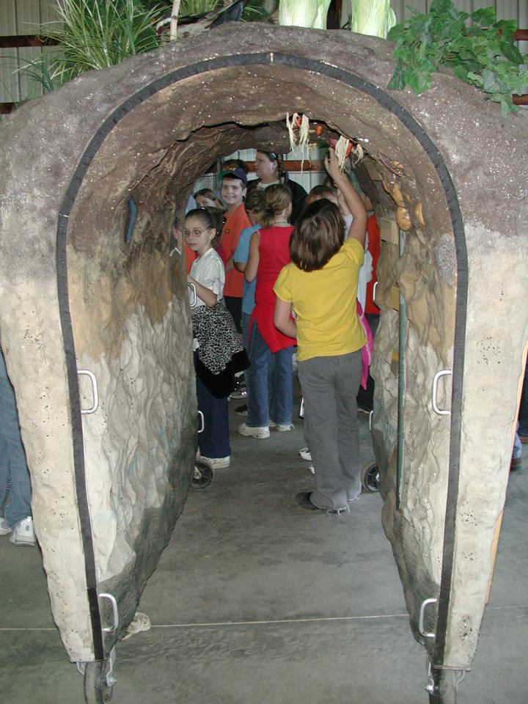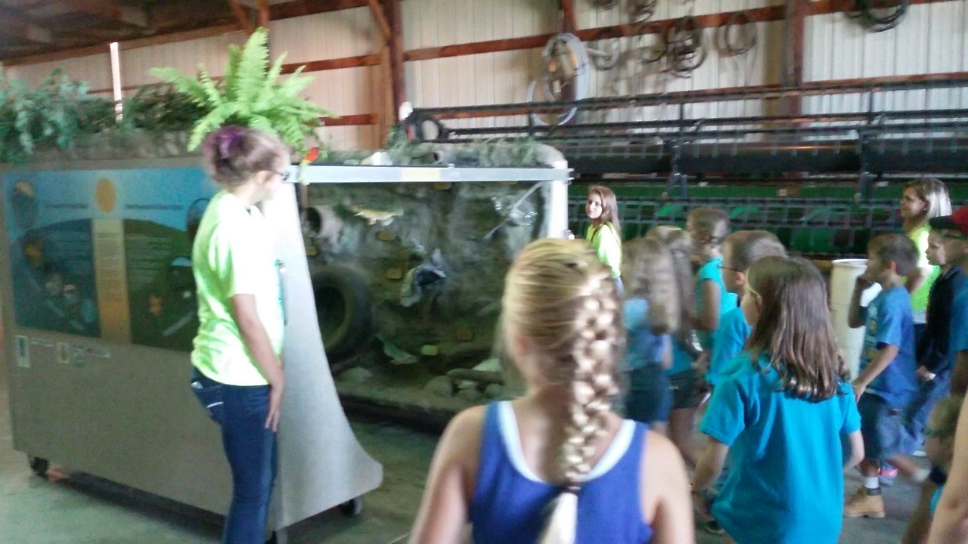

The Tunnels help teach Soil and Water conservation and are great hands on learning tools for students. These tunnels were made possible by grants from local Foundations including,
Farm Bureau, Midland Cogeneration Venture, The Dow Chemical Foundation, Rolland M. Gerstacker, Future Farmers of America, Saginaw Bay WIN, Three Rivers Construction,
Charles J Strostacker Foundation, S.C. Johnson, and Midland Area Community Foundation,

The Tunnels are for rent to partners and organizations. All proceeds go to maintenance and upkeep on the trailers. We are currently seeking a donation or a grant for a pick-up truck to haul them to locations.

Annual 4th Grade Farm Tour Marks 32 Years in 2019!

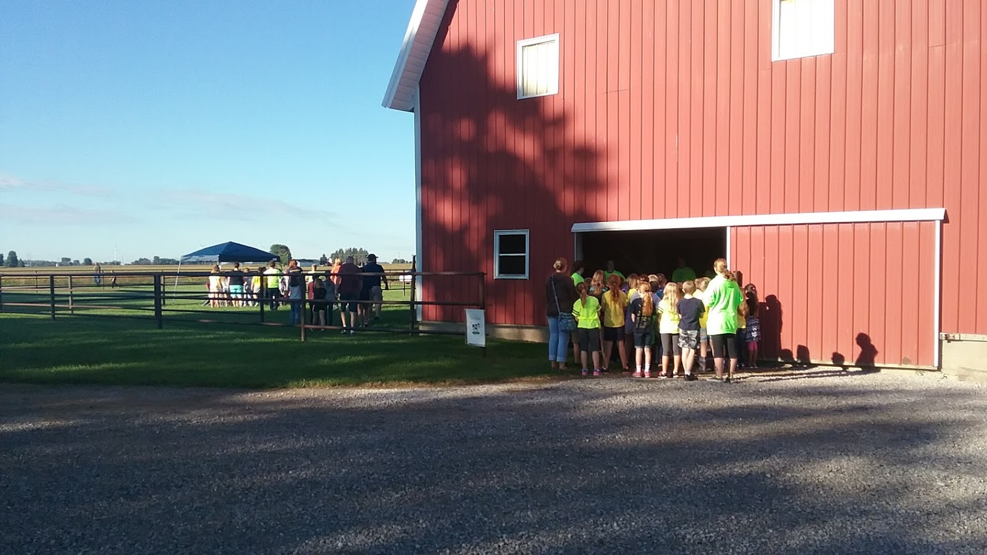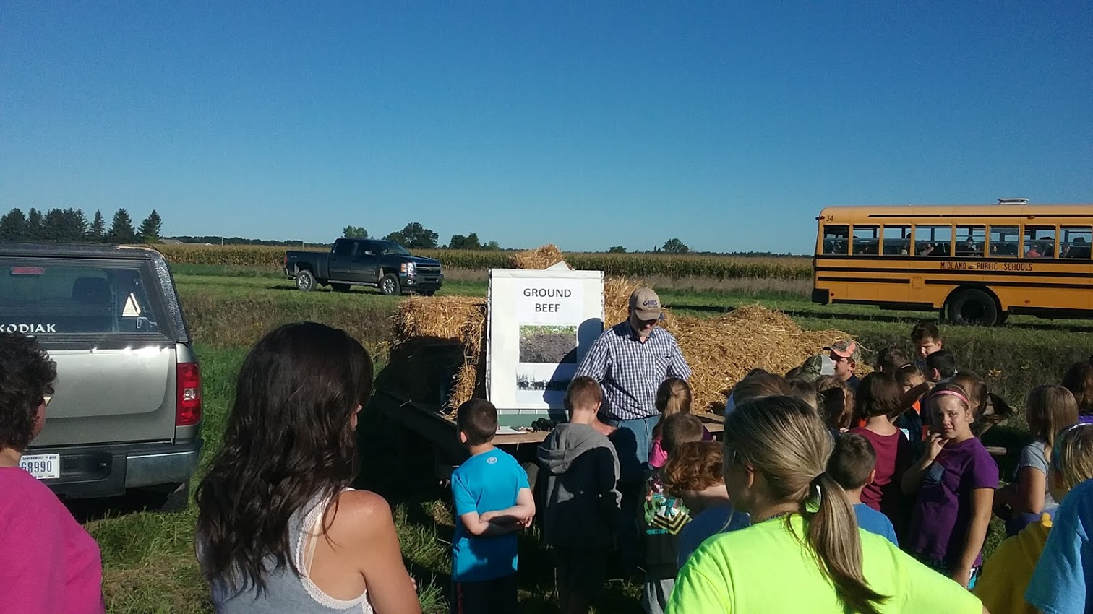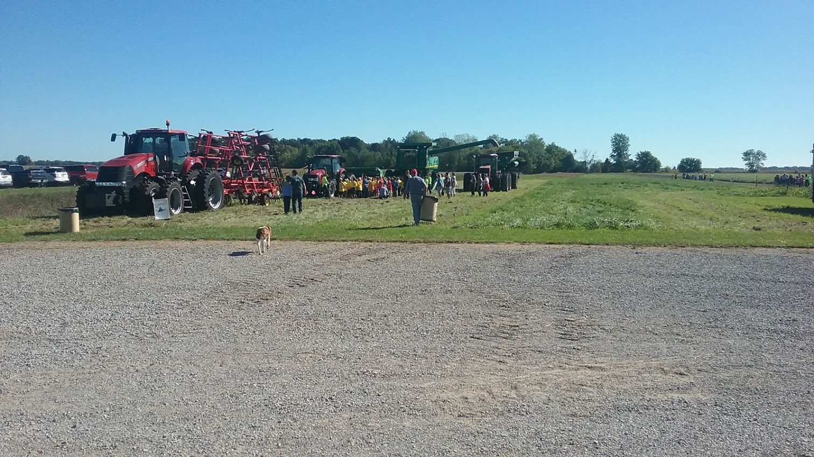

Started in 1987, September 2019 will marked the 32th year of the 4th Grade Farm Tour hosted by the Laurenz Family Farm and Breckenridge FFA and sponsorships from The Exchange Club of Midland, Gleaner Life Insurance Society Thrivent Financial and Midland Conservation District.

4th grade classes, over 500 students from schools in Midland Co are invited for hands on education in farming and conservation. The FFA provides tour guides for 16 stations that include, Farm Animals, Petting Animals, Containment Shed & Technical Information, Corn Classroom, Corn Maze, Grain Hauling and Storage, Soils, Earth and Water Tunnels, Popcorn, Dairy Demonstration, Farm Machinery, One Acre Plot, Bugs on the Farm, Michigan Pork Producers, All Food Comes from the Farm and FFA Organization Opportunities.

If you’d like to donate to this Program Contact the Midland Conservation District, go to our web site for more information and pictures of this event.

Conservation Matters
Educational Show on MCTV

In 2106 we produced 10 Shows. With the help of Joan Timmer, HAP participant and District supporter as the director and the great volunteers at MCTV we created a television show to inform and educate the public on conservation issues and practices

1. Who are we and what do we do,
2. Tree Sale Program,
3. Planting Trees. Why Plant Trees, How to Plant Trees,
4. Creating Wildlife Habitat,
5. Pollinators: What are they and what do they do,
6. Invasive and Natives what are they and why should we care,
7. Grazing Management,
8. Hunting Access Program,
9. Founding Fathers-Founding Farmers and
10. Back Yard Conservation.

Look for it, “Conservation Matters” on the local MCTV Community Voices Channel.
On Charter Communications and AT&T U-verse. Or Go to the MCTV Website http://www.cityofmidlandmi.gov/457/Whats-On-Now Community Voices Channel and search Conservation Matters.
Or you can go to our website, www.midlandcd.org, where all shows are available by clicking on the link to watch.

We did not record any new shows in 2017-2018, due to the flood in June of 2017 closing the MCTV recording studio,

Karen continues to volunteer at MCTV recording events and enjoys the opportunities it has to offer. Karen reported approximately 25 hours of volunteer time for MCTV. Karen did shows in 2018, including the Arenac Conservation District Farm Tour and Dahlia Hill, a Tribute to Charles and Ester Breed.
Contact us if you’d like to suggest a topic for a show.

Working with Students in our Community
Coleman Agriscience Forestry Class

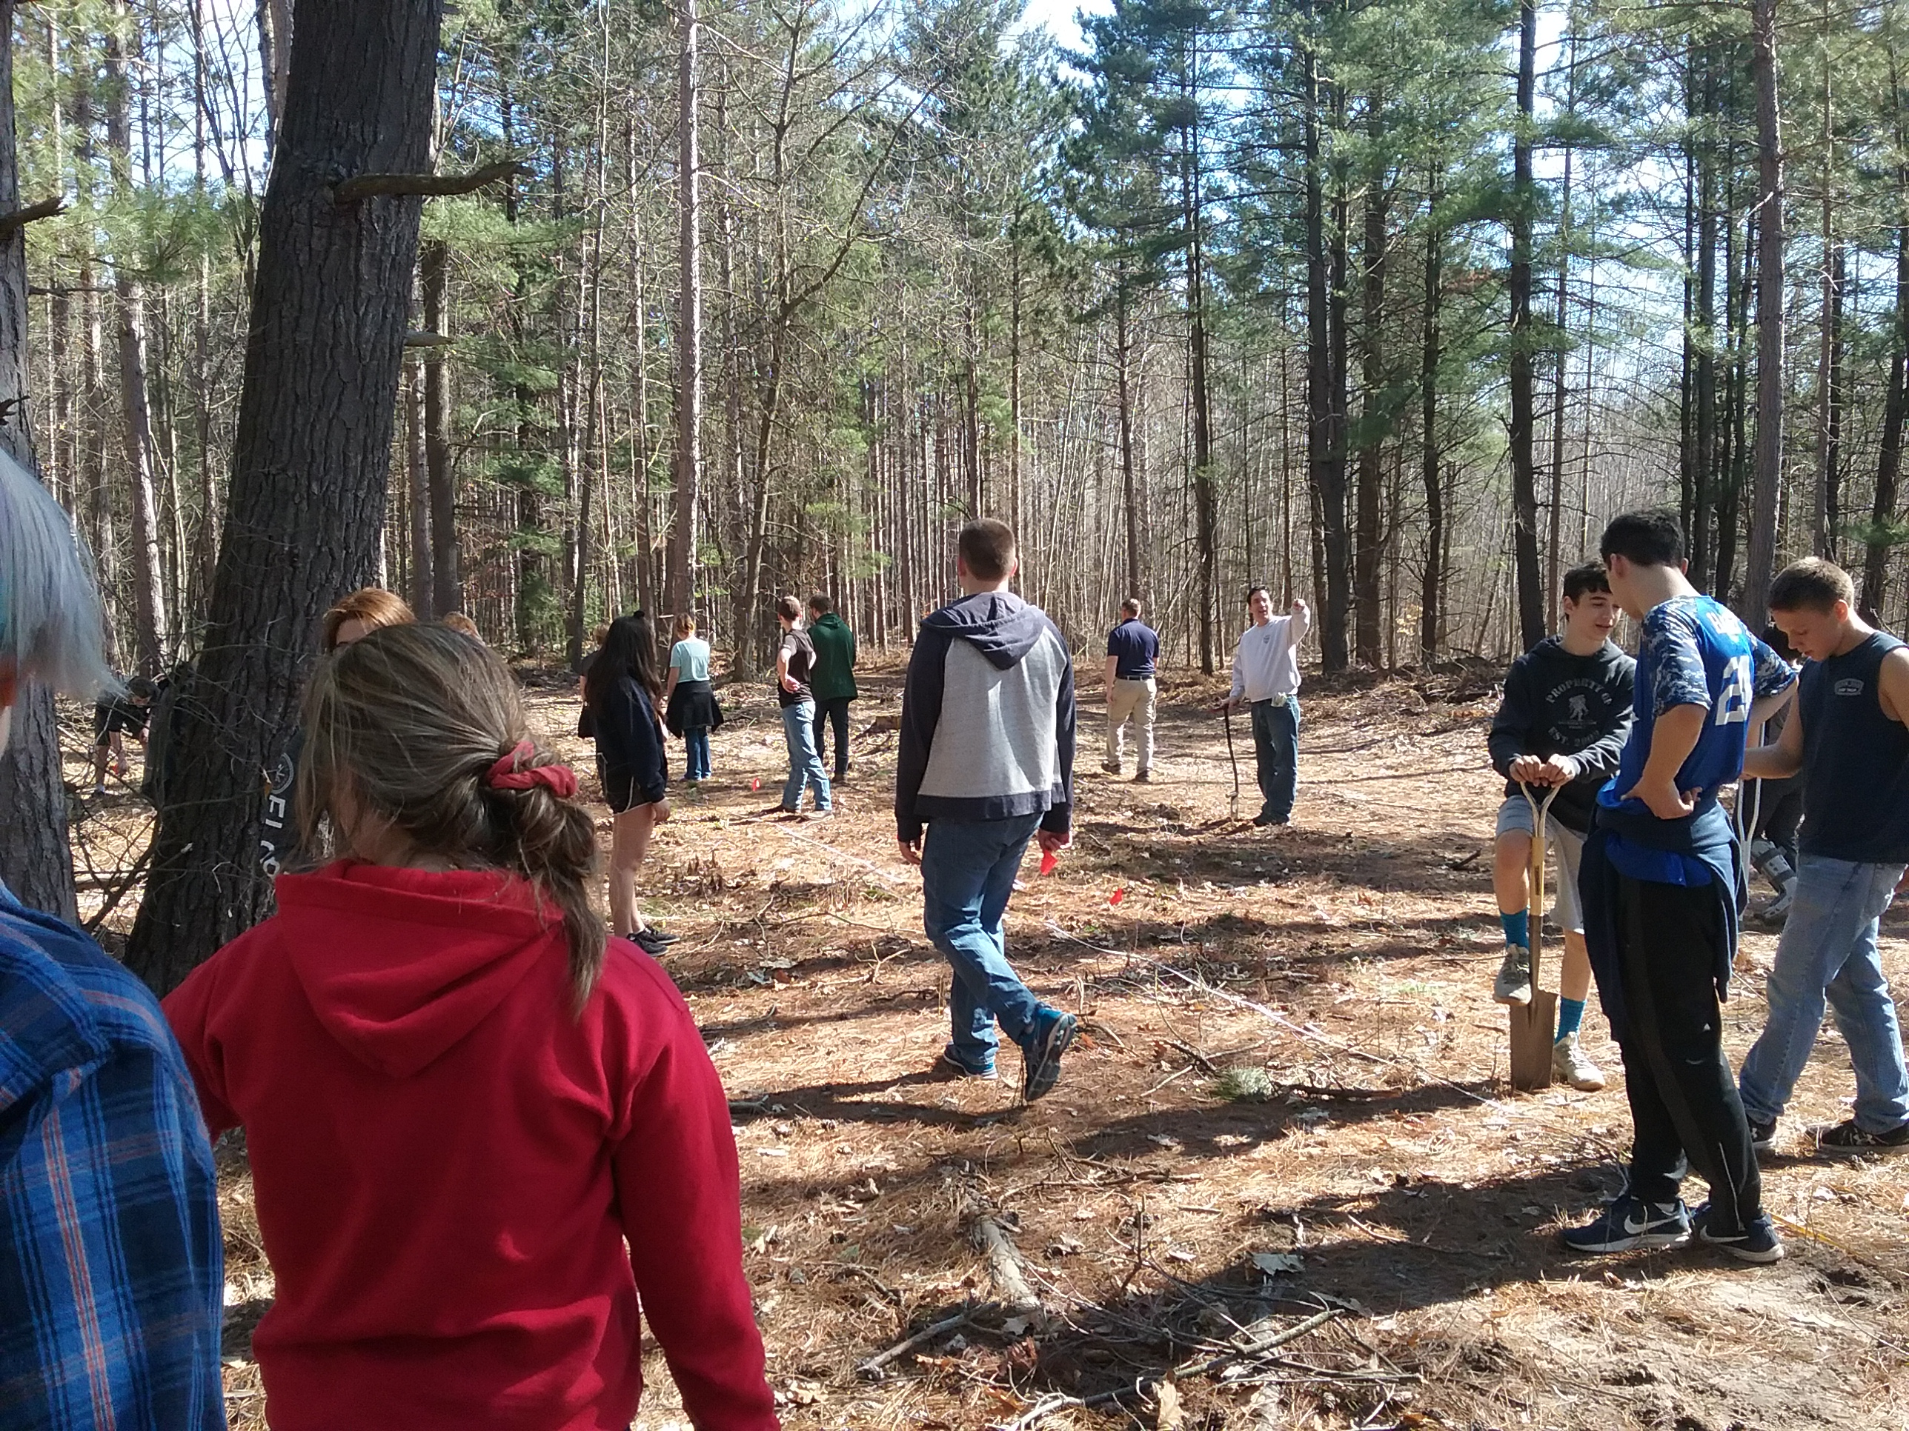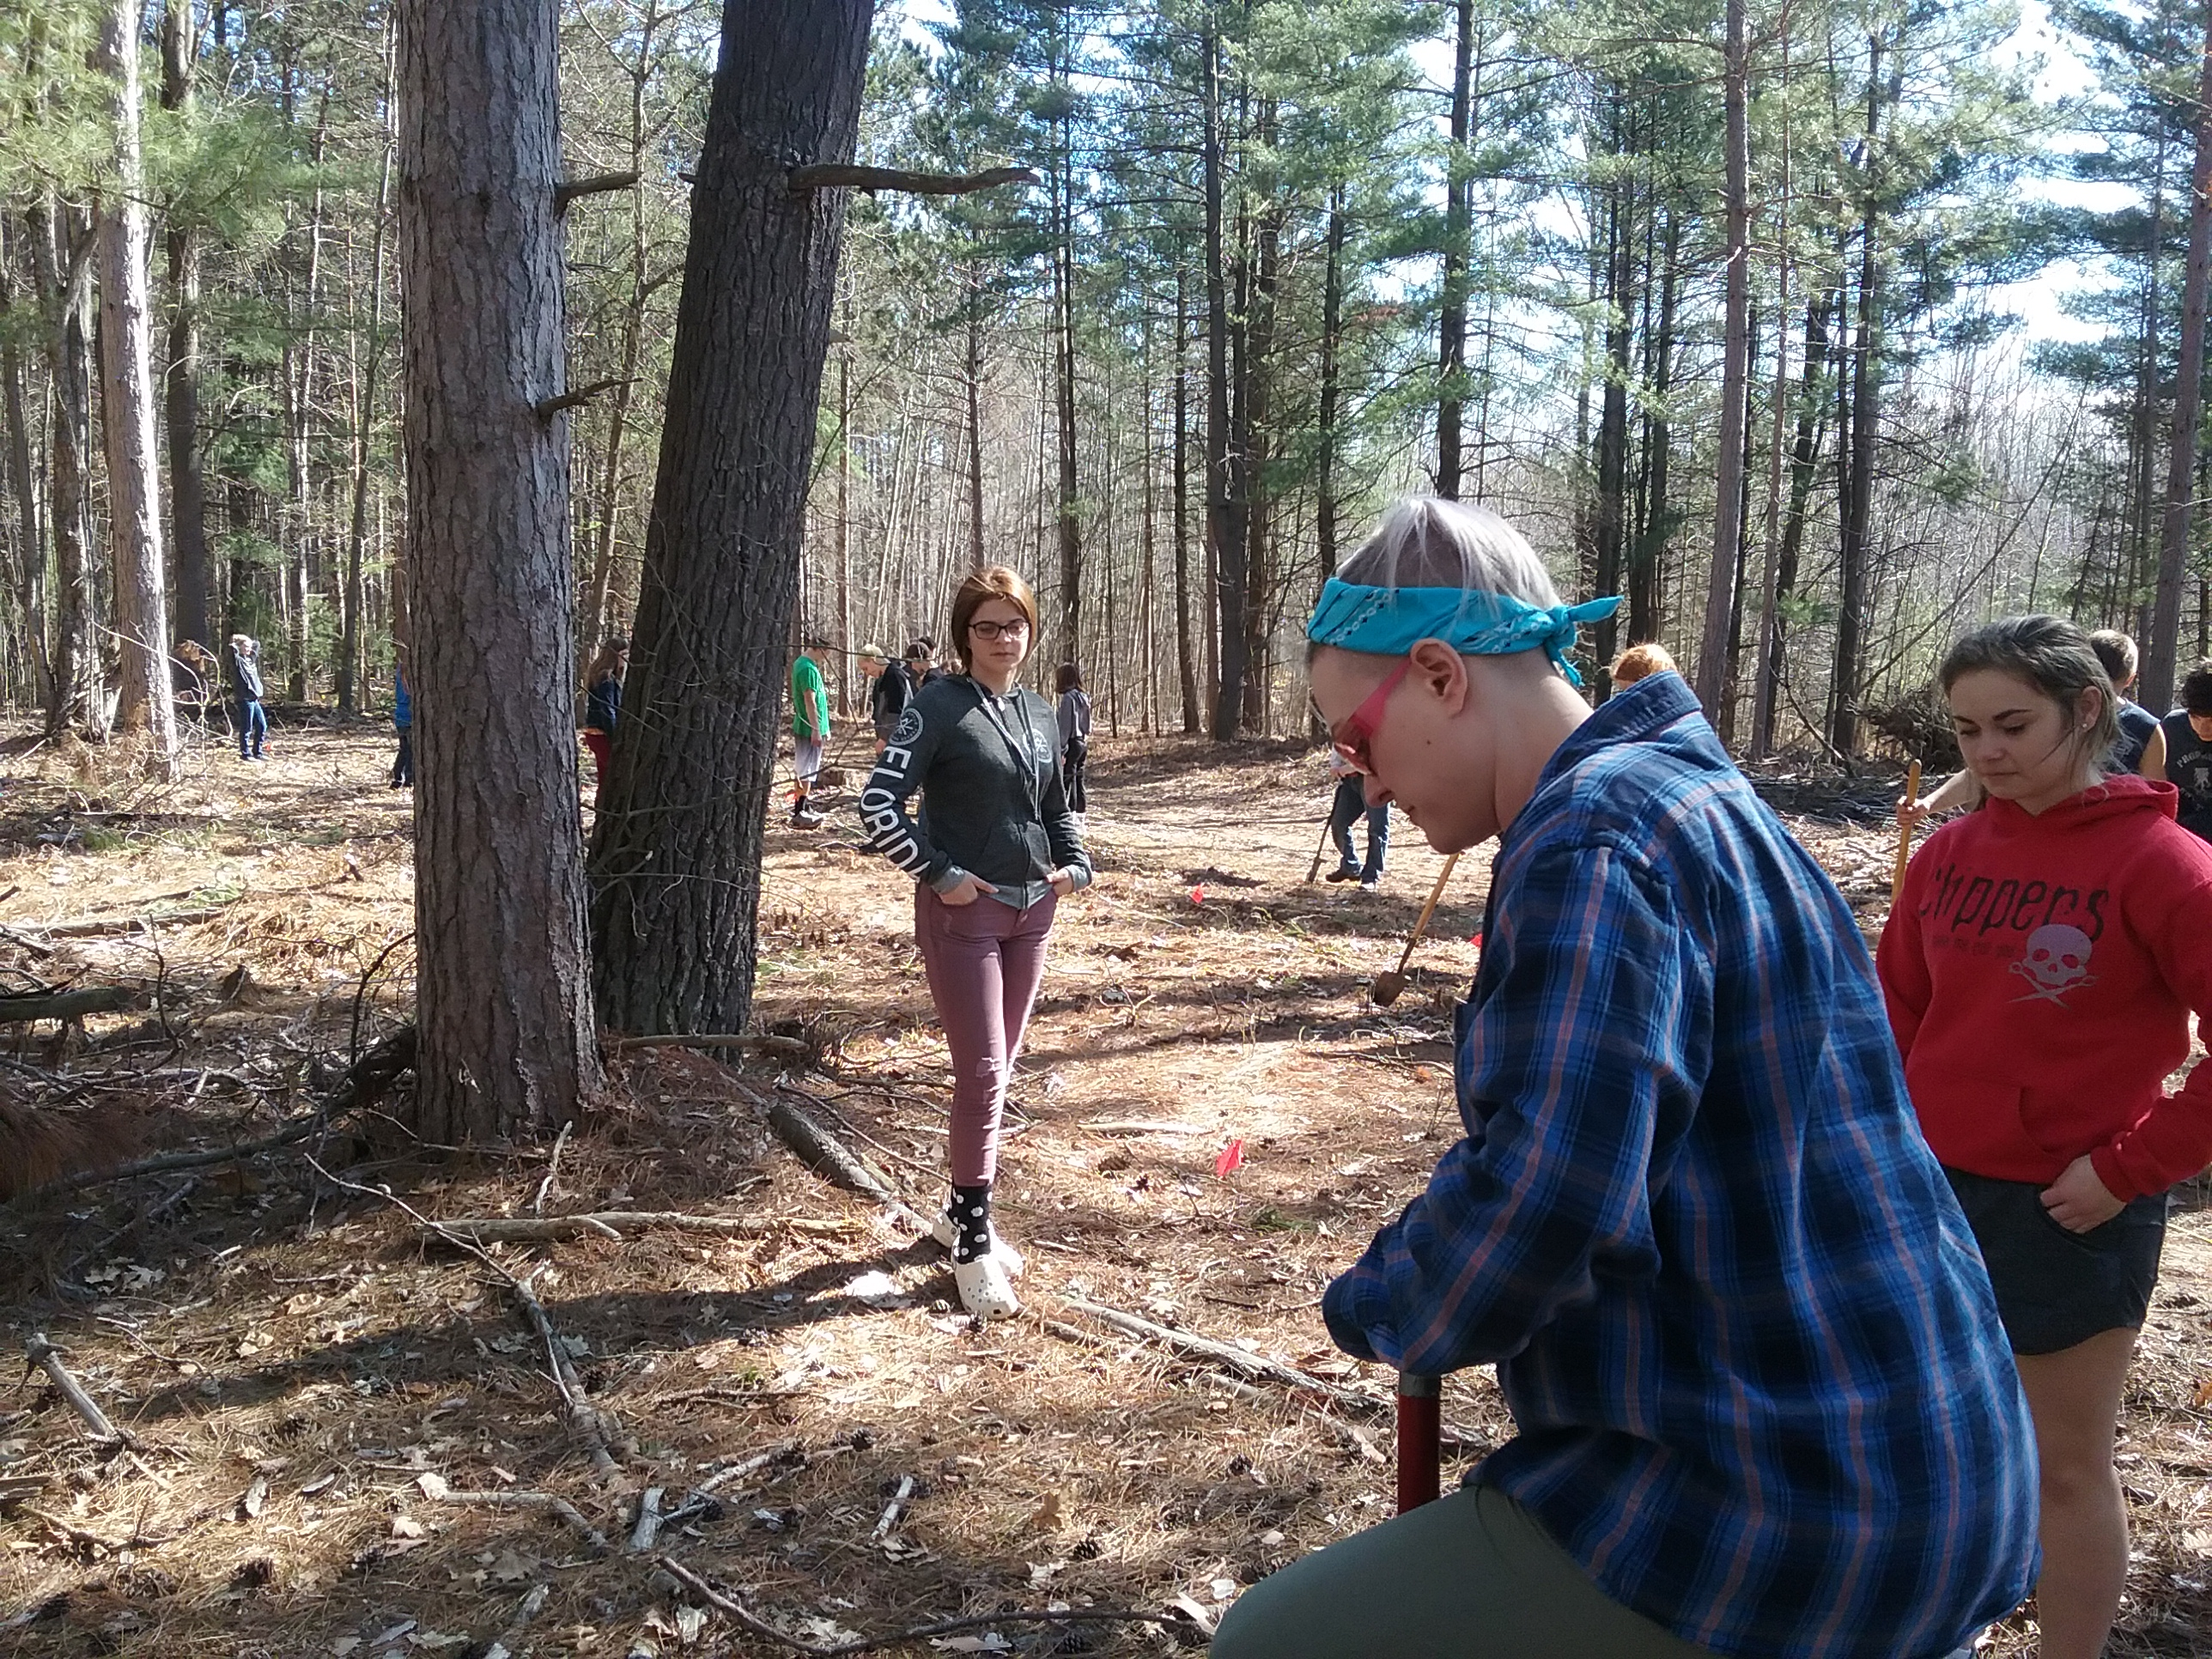

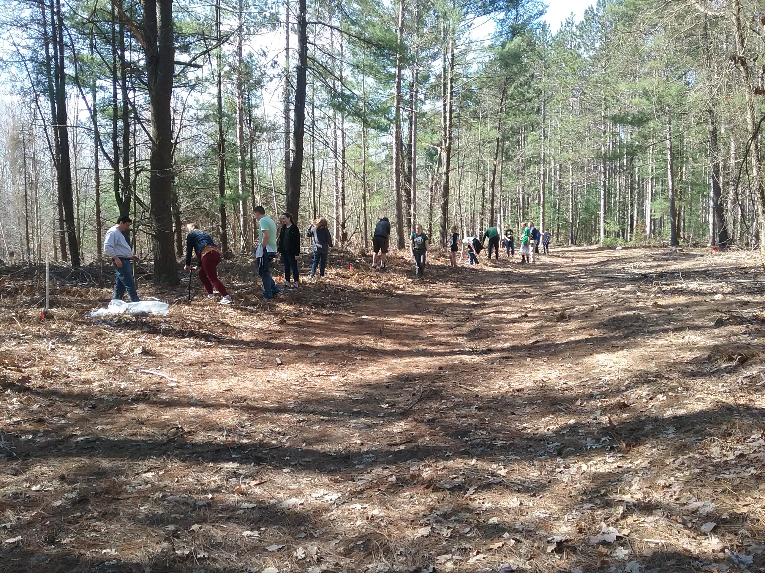

On April 22, 2019 we donated and helped plant approximately 100 trees in the 80 acre forest on Fike Road.with the Coleman Agriscience Class and plan on supporting this project as much as we can.

The Coleman Regional Agriscience Center draws students from Clare, Gladwin and Midland counties to study Agriscience in a whole new way.
Students earn High School and College Credits, Plus Industry Certifications.
Actively participate in a variety on hands on activities and job shadowing.
More than Farming Agriscience offers ACRES of Opportunity!
Agriscience Careers include,
Agriscience Educators, Golf Course Superintendent, Veterinarian, Wild Life Biologist, Dairy Producer, Farmer Rancher, Agricultural Journalist, Botanist, Embryo Technologist, Commodity Broker, GPS Technician, Chemical Dealer or Sales Rep, GPS Technician, Supply store Manager, Food Scientist, Dietitian, Wildlife Manager Just to name a few!
This program also includes Leadership Training, Public Speaking, Job interview and career preparation, Parliamentary procedure, Service learning and community service, attending conventions and competitions.

Northwood University Students for Sustainability.

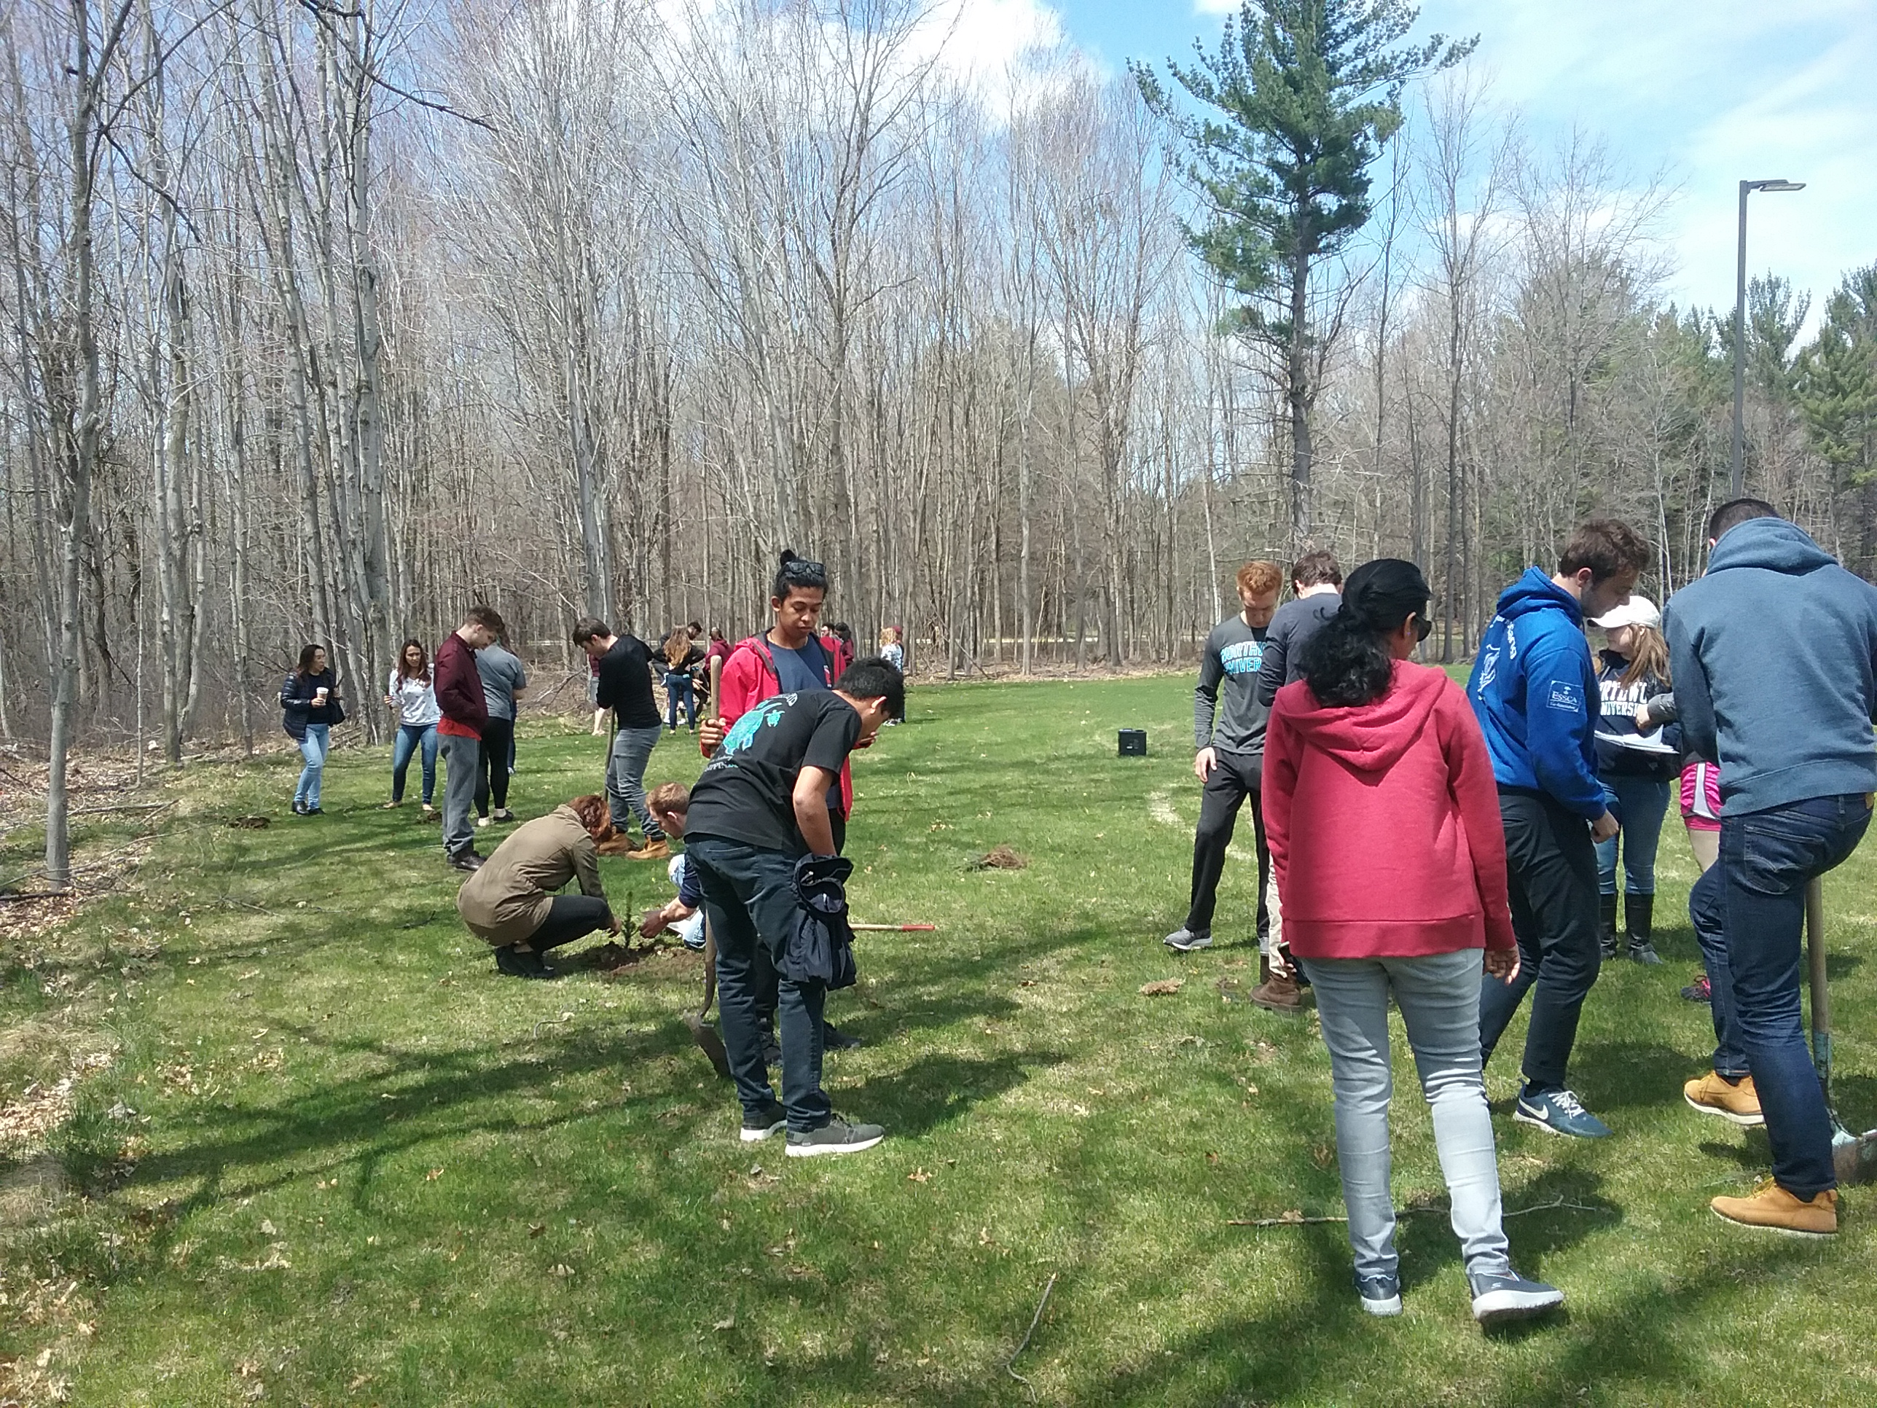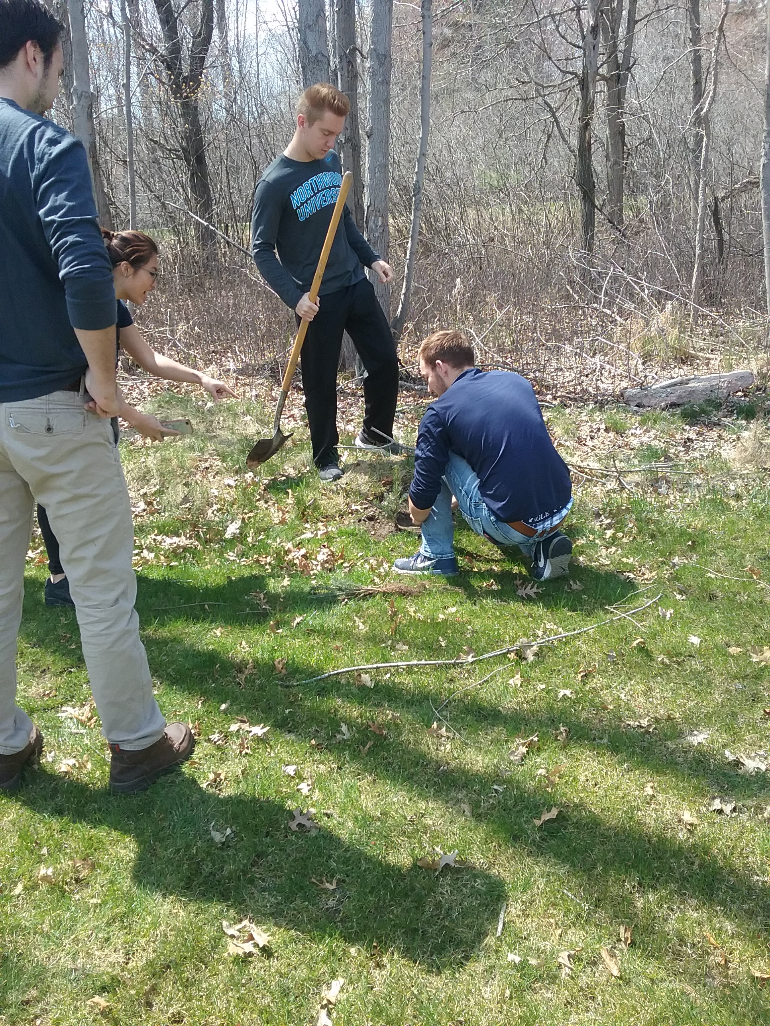

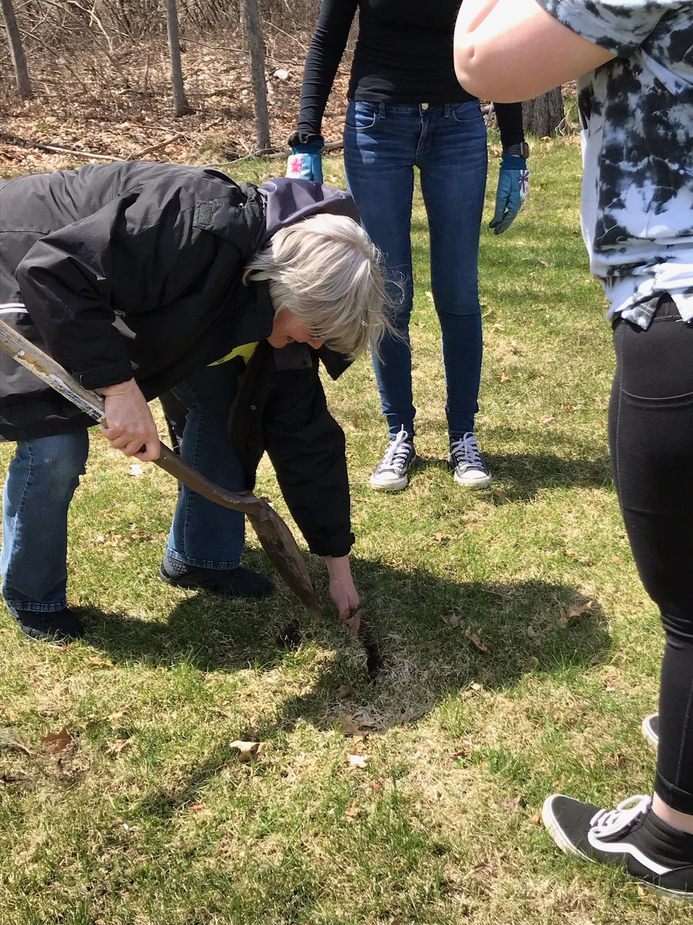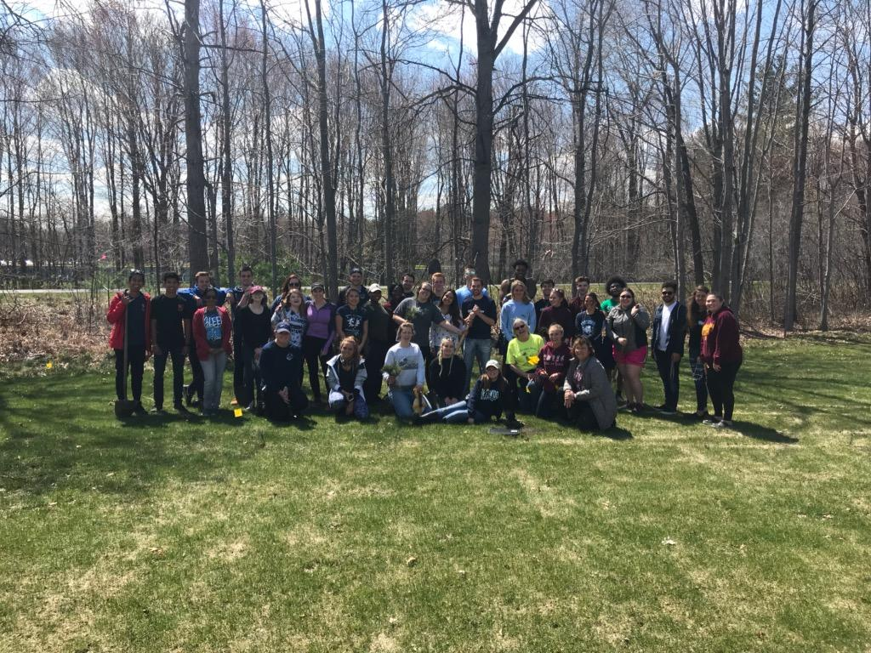

On April 26, 2019 we donated 200 trees to the Northwood Students for Sustainability Class and helped plant them on an open lot near their new dorms. We had a great time and created a great partnership and friendships for the future.

Northwoods Students for Sustainability helping with Barn cleanup.

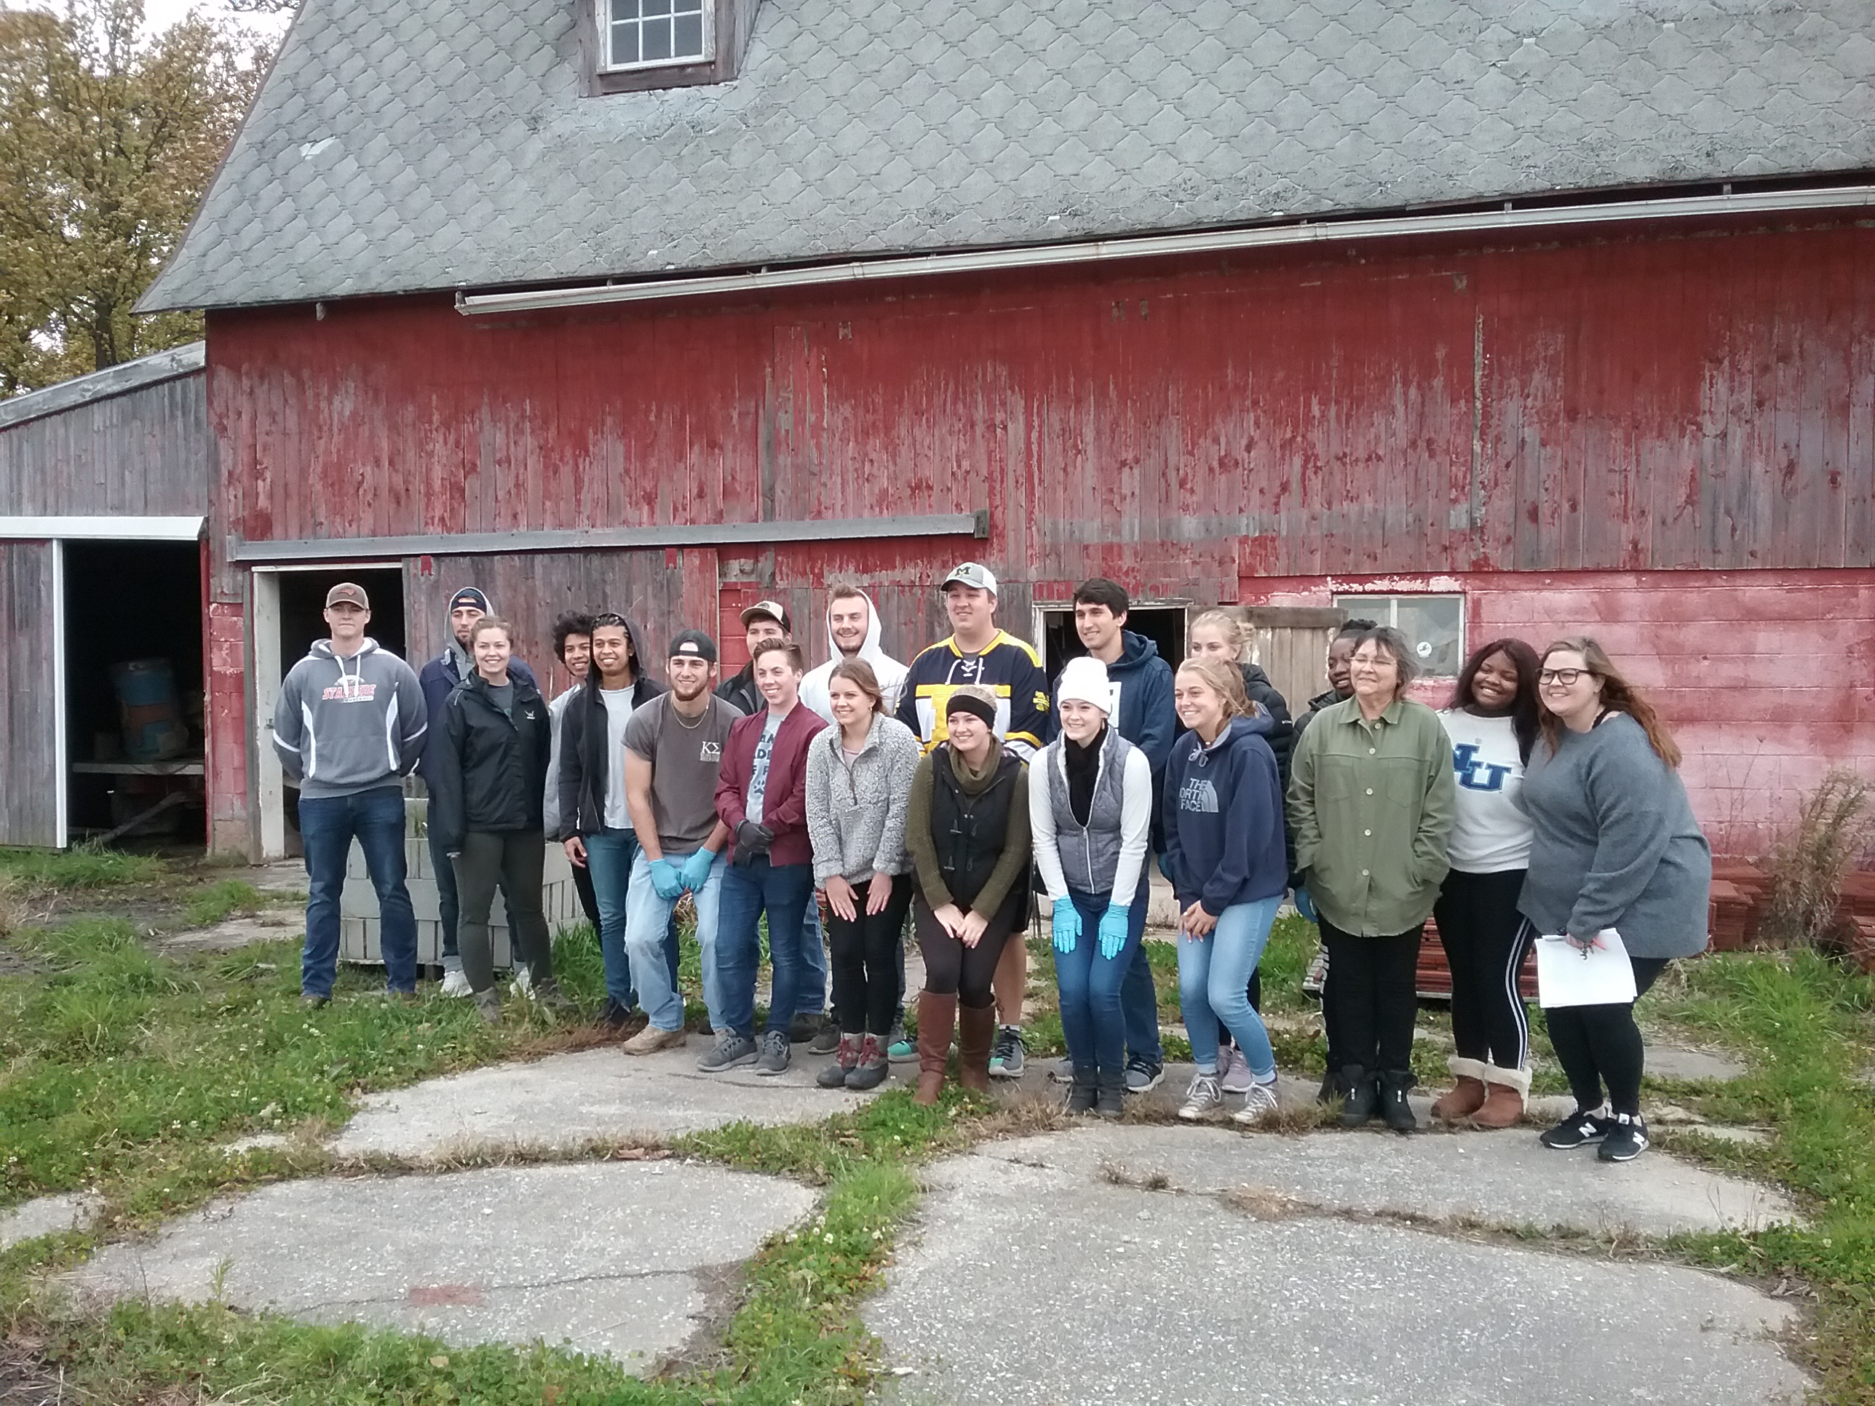

Other District Activities

In April 2019 we donated trees to the following:
We helped Whiting Forest out with a donation of white pine seedlings when they were running short for their project,
We also donated trees to Little Forks Conservancy for plantings on their properties.

The Administrator has certifications in American Forest Foundation Project Learning Tree, And the DNR Project Wild and working on creating educational programs targeted to K-8 grade students to provide Environmental and Conservation related Education. Working on incorporating the Soil and Water tunnels into these programs.

Workshops and informational programs,
we’ve hosted informational workshops for the public on How and Why to Plant Trees and Backyard Conservation.
In February of 2016 we hosted a workshop about the Feral Swine problem in Midland County which had 65 attendees.
In July 2018 we did a talk with approximately 40 students at Michele’s Montessori about Bee’s and Pollinators and in February 2018 we did an informational talk about becoming a beekeeper (Beekeeping 101) for approximately 35 people at Creative 360 Studio Annual Seed Swap.

We were invited to speak at the Home Builders of Midland Association annual meeting on Chronic Wasting, Hunting and Food Plots.

We held a poster contest for the 4th grade students that participated with the Annual Farm Tour. We had 63 entries and 63 excited students that learned a lot from their farm visit.

We have been e-mailing a quarterly newsletter to over 300 local supporters.
Email addresses were collected at tree sales, workshops and other events.

Midland Conservation District also has a working agreement with NRCS, to provide administrative and technical support to the Midland NRCS Field office to work on Great Lakes Restoration Initiative and facilitate Farm Bill contract management and practice implementation.
We have been working with landowners and FSA on new contracts, renewals and day to day operations.

Midland Conservation District
Annual Plan of Work Fiscal Year
October 1, 2019- September 30, 2020

1st Quarter October 1, 2019- December 31, 2019
News Letter to Customers, Foundations and Township Supervisors. QTR. Report to Commissioners.
Tree Sale Planning: Finalize tree sale Budget Dec. meeting. Get Mailing list together. Out by Jan. 15
Quarterly Reports Due Dec. NRCS, NACD, HAP, MDARD Audits, Budget Review.
MACD Annual Fall Conference October 28-20, Shanty Creek MI
State of the Bay Conference Bay City Sept 26, 2019
Garden Club Meeting Oct.4,2019
Farm Tour Poster Collection/follow up with classes.
Board Meetings: Oct.15, Nov.19, Dec.17.

2nd Quarter January 1, 2020 – March 30, 2020
News Letter to Customers, Foundations and Township Supervisors. QTR. Report to Commissioners.
Workshops: Feb 13, Hemp-You think it’s Pot but it’s Knot, March 11, Trees 101, April 1, MAEAP Phase 1
Tree Sale Orders due by April 3,2019. Distribution April 20 thru 25, Native Tree and Plant sale April 27 thru May 9
Annual Meeting/Election Planning: Date May 21, 2019, update annual report and Resource assessment, plan meeting according to MACD Standards, Go over Election Procedures By March Meeting.
January, District and Directors Policy Review and District Evaluation.
Quarterly Reports Due March. NRCS, NACD, HAP, MDARD Audits, Budget Review.
Board Meetings: Jan.21, Feb.18, Mar.17.

3rd Quarter April 1, 2020 – June 30, 2020
News Letter to Customers, Foundations and Township Supervisors. QTR. Report to Commissioners.
Tree Sale Distribution: April 18-30, 2019 (STC)
CNC Earth Day: Seedling give away.
Earth Day Celebrating 50 years
MACD Summer Conference June.
Workshops: TBD June Pollinator Week, Backyard Conservation.
Quarterly Reports Due June. NRCS, NACD, HAP, MDARD Audits, Budget Review.
Board Meetings: Apr.21, May19, June 16.

4th Quarter July 1, 2020 – September 30, 2020
News Letter to Customers, Foundations and Township Supervisors. QTR. Report to Commissioners.
Budget Planning: August Meeting
Appropriations Act Planning: September Meeting
4th Grade Farm Tour: September 2019 Follow up with Classes that attend. Farm Tour Poster Contest.
MACD Fall Conference. TBA
MCTV Shows: Workshop: ????How and Why a wetland is Determined. Cover crops, soil health
Quarterly Reports Due Sept. NRCS, NACD, HAP, MDARD Audits, Budget Review.
Board Meetings: July 21, Aug.18, Sept.15.

5 Year Plan of Work:
Develop more education programs with barn. Secure a donation for a vehicle to haul Educational Trailers.

With this comes a lot of Training
Our Administrator has been to the following trainings:
2016
Keys to Successful Tree Planting: 2-12-16
Green Infrastructure for Business: 11-22-16
Residue and Tillage Management in Organic Farming Systems: 10-4-16
Addressing Resource Concerns, Evaluating, Documenting and Reporting Progress. 10-28-16
Conservation Planning 2015: 10-28-16
Environmental Compliance for Conservation Assistance Level 1: 11-14-16
Environmental Compliance-CPA 52 Training: 12-1-16

2017
Project Learning Tree Certification: Petoskey, MI 1-7-17
Conservation Planning Part 1: February 7, 2017 (on line)
Cultural Resources Training Series Part 1: February 7, 2017 (on line)
Great Lakes Watershed Management System Training Workshop: March 16, 2017
Wetland Delineation Training for CRP and CP23A: July 20 & 21, 2017
Tool Kit Training: July 18, 19 & 20, 2017
Forest Stand Improvement: August 2 & 3, 2017
Millage Campaigns and Marketing, District Managers Retreat: August 10, 2017
Cultural Resources Training Modules 7&8: October 3, 4,& 5 2017 in Mt Pleasant.
2017 State of the Bay Conference: September 27, 2017
Project Wild Certification (DNR): November 1, 2017

2018
NRCS Conservation Planning Classroom/Field Training May 7-11, 2018
Nutrient Management Training One on One with Boyd in Flint 5-21-18
MACD Summer Conference Bay City June 4,5,6 2018
CRP -SAFE Training in Bay city 6/27/2018
Cover Crop Inter seed it Workshop Frankenmuth, 7/11/2018
CRP-SAFE Signup Training Workshop Webinar 7/13/18 8:30am-11:30am
Saginaw Bay Watershed Conservation Lunch & Learn, Cover Crops, 8/7/2018
Region 6 Meeting, 8/29/2018
MAEAP Goal Setting Meeting 9/14/2018
Mackinac Center for Public Policy Conservation Round Table 10/25/2018
MACD Fall Conference Shanty Creek Oct 29-31, 2018

2019
SWCS Seminar-A Matter of Balance March 6, 2019
Perceptions, Engagement and Partnerships for on farm conservation
MACD Summer Conference Bay City June 3rd & 4th, 2019
Grazing Management Workshop July 10, 2019
CISMA Partner Meeting July 18, 2019
MACD Managers Retreat August 19, 2019 Jay’s Sporting Goods on Advocacy
State of the Bay Conference 9-26-2019, State of the Bay Report Card Watershed Issues
and Management, Environmental Education, Toxics, Restoring and Emerging Issues.
Septic Systems and Water Quality,
Nature Conservancy Lunch & Learn 10-8-2019 Farm Resiliency in Wet Weather.
MACD Fall Convention Oct 28 through 30, 2019
2020 Monthly Meeting Schedule
Location: USDA/NRCS Service Center Meeting Room
954 E Isabella Rd Midland MI. 48640. Time 7:00pm-9;00PM

October 15, 2019
November 19, 2019
December 17, 2019
January 21, 2020
February 18, 2020
March 17, 2020
April 21, 2020
May 19, 2020 Annual Meeting Details TBA
June 16, 2020
July 21, 2020
August 18, 2020
September 20, 2020

The Meetings will be held under the provisions or the Open Meetings Act (Public act 267 of 1976) at the USDA-NRCS Service Center Office located at 954 E Isabella Rd. Midland, MI 48640 (989) 835-1921
*If there is a change in schedule, within 3 days of the meeting in which a change is made, the Midland Conservation district will post a notice stating the new dates, times and places of regular meetings.
*Special Meetings must be posted at least 18 hours in advance. The notice will include date, time and place of the meeting.
*The Open Meetings Act provides provisions for the public to address the District board during the meeting.

Contact information:
E-mail midlandconservation@macd.org
Phone: 989-486-2325
Hours: Monday through Friday. 8am-4:30pm

